Trend App Deployment - Screenshots Document

**1. Git Cloning**

1a) Git cloning the react application build output folder

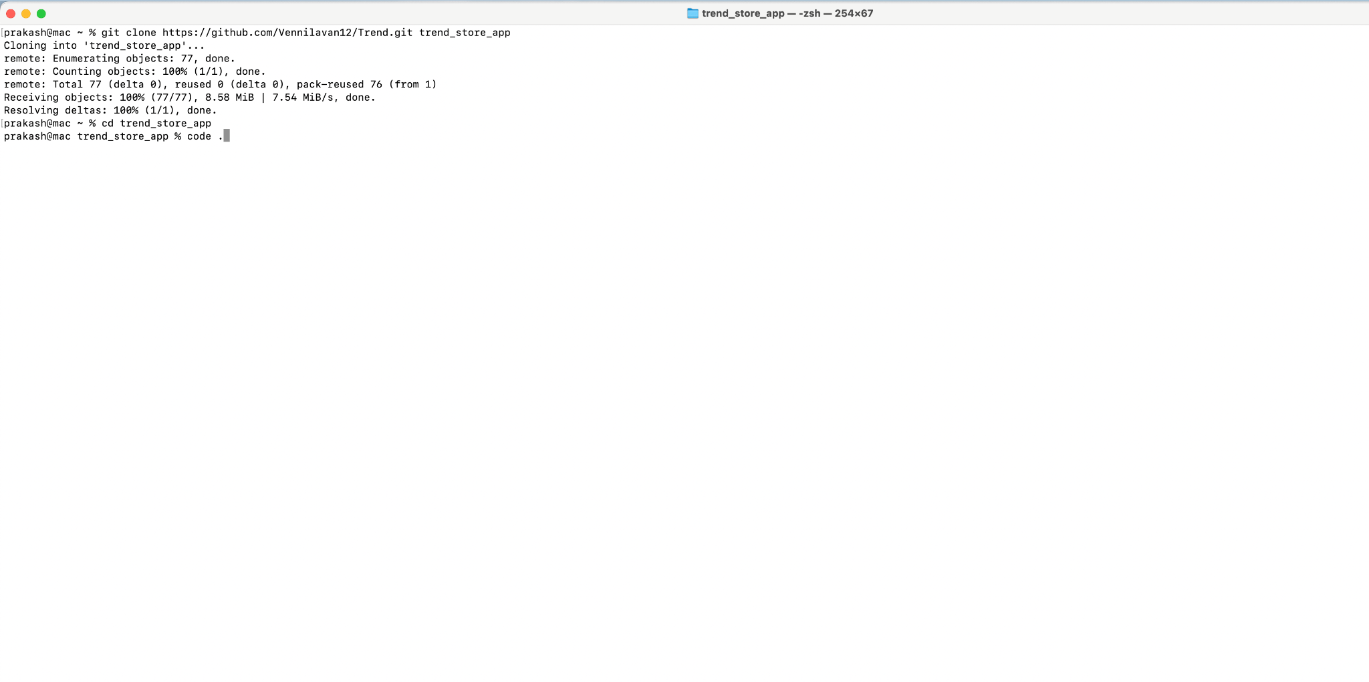

—---------------------------------------------------------------------------------------------------------------------------------------------------------

**2. Docker Build and Push**

2a) Adding Config files to project

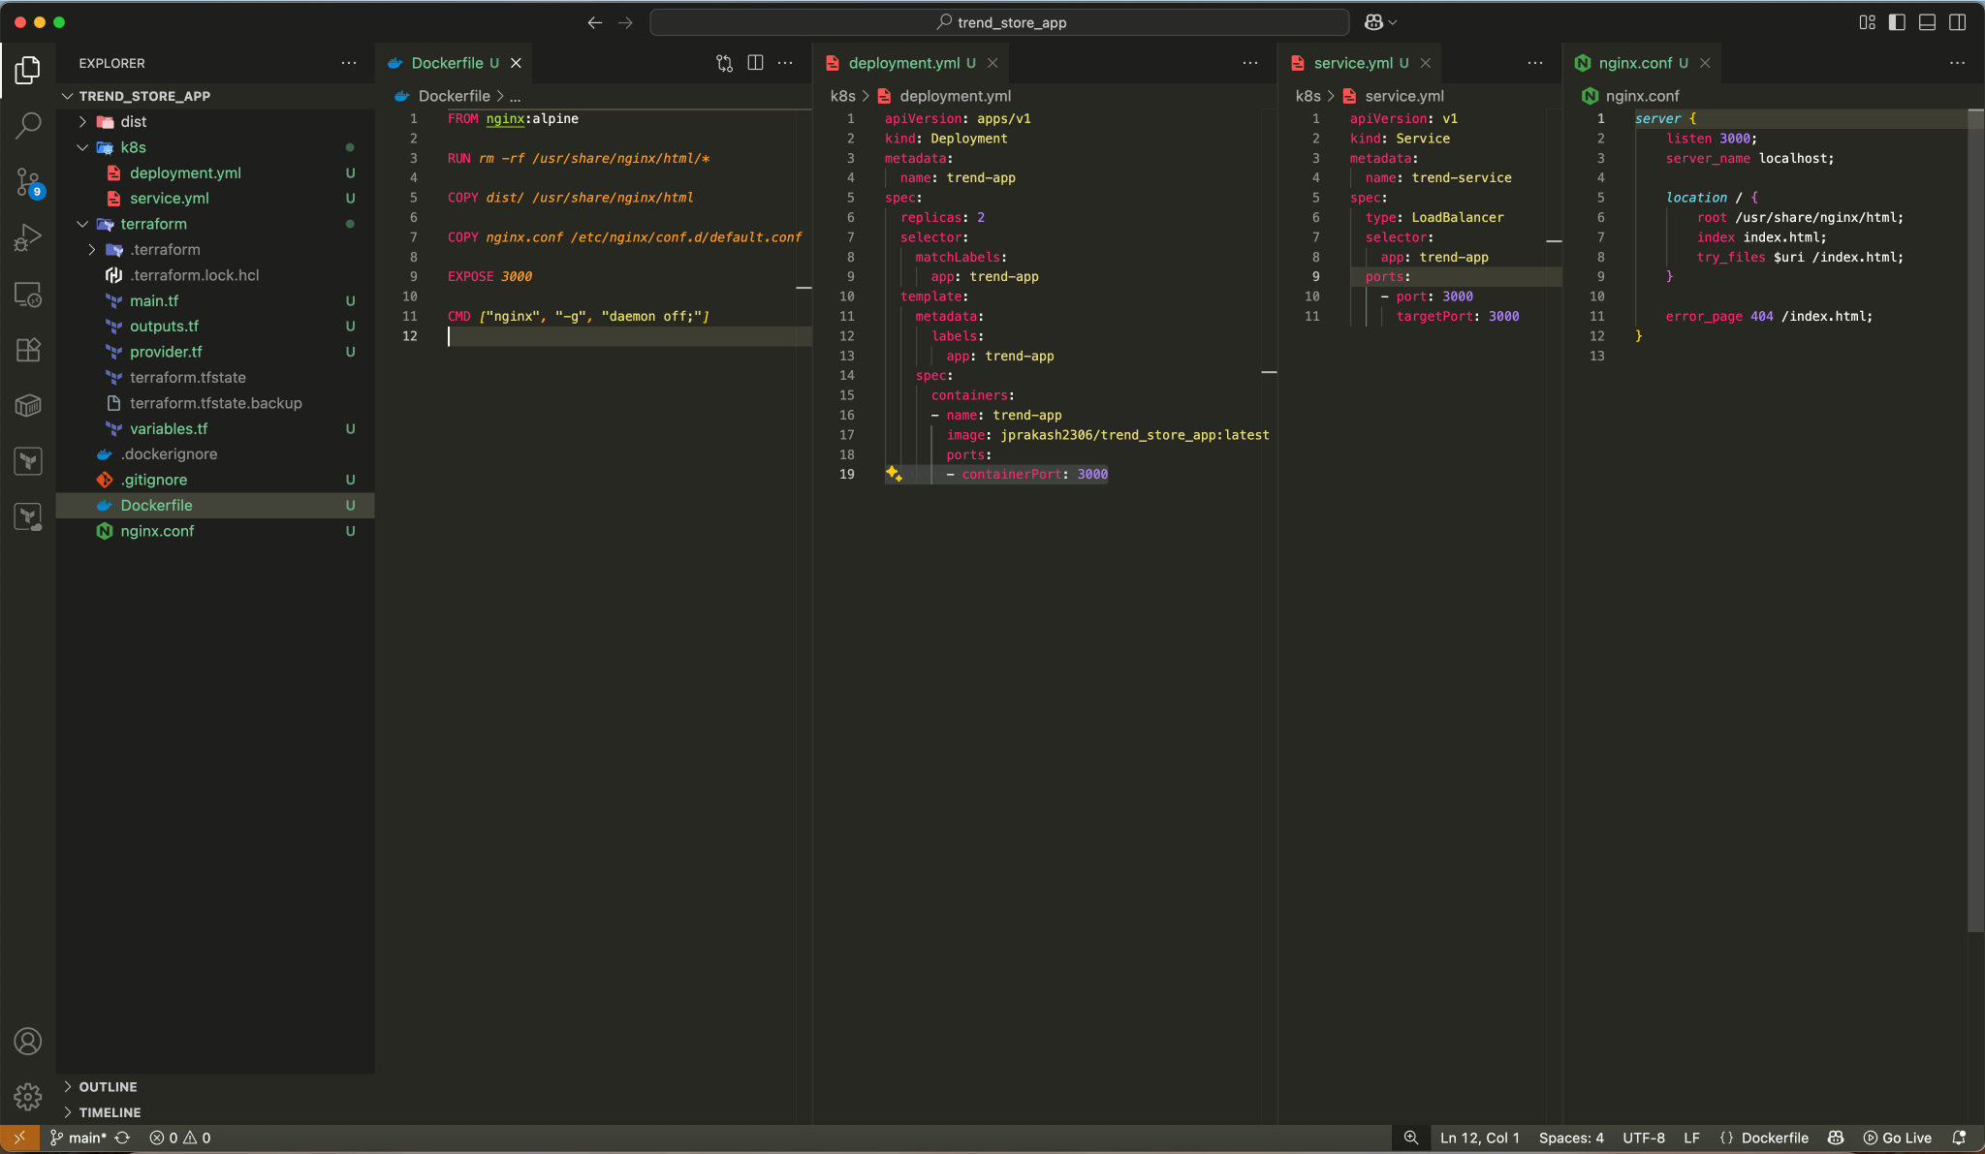

2b) Build docker image using Dockerfile and running on local machine  
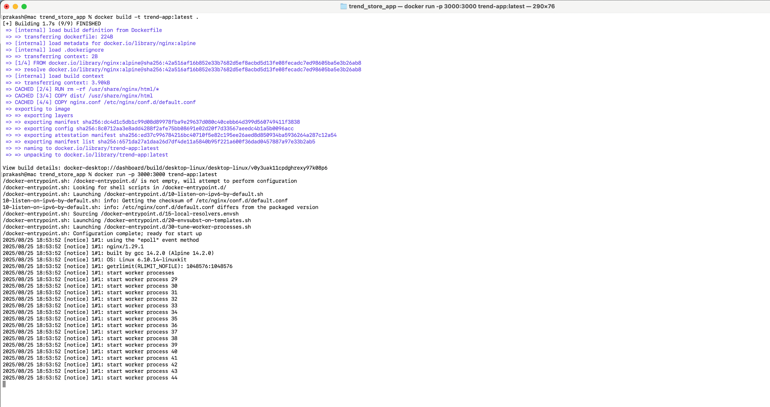

2c) Running on local machine on port 3000

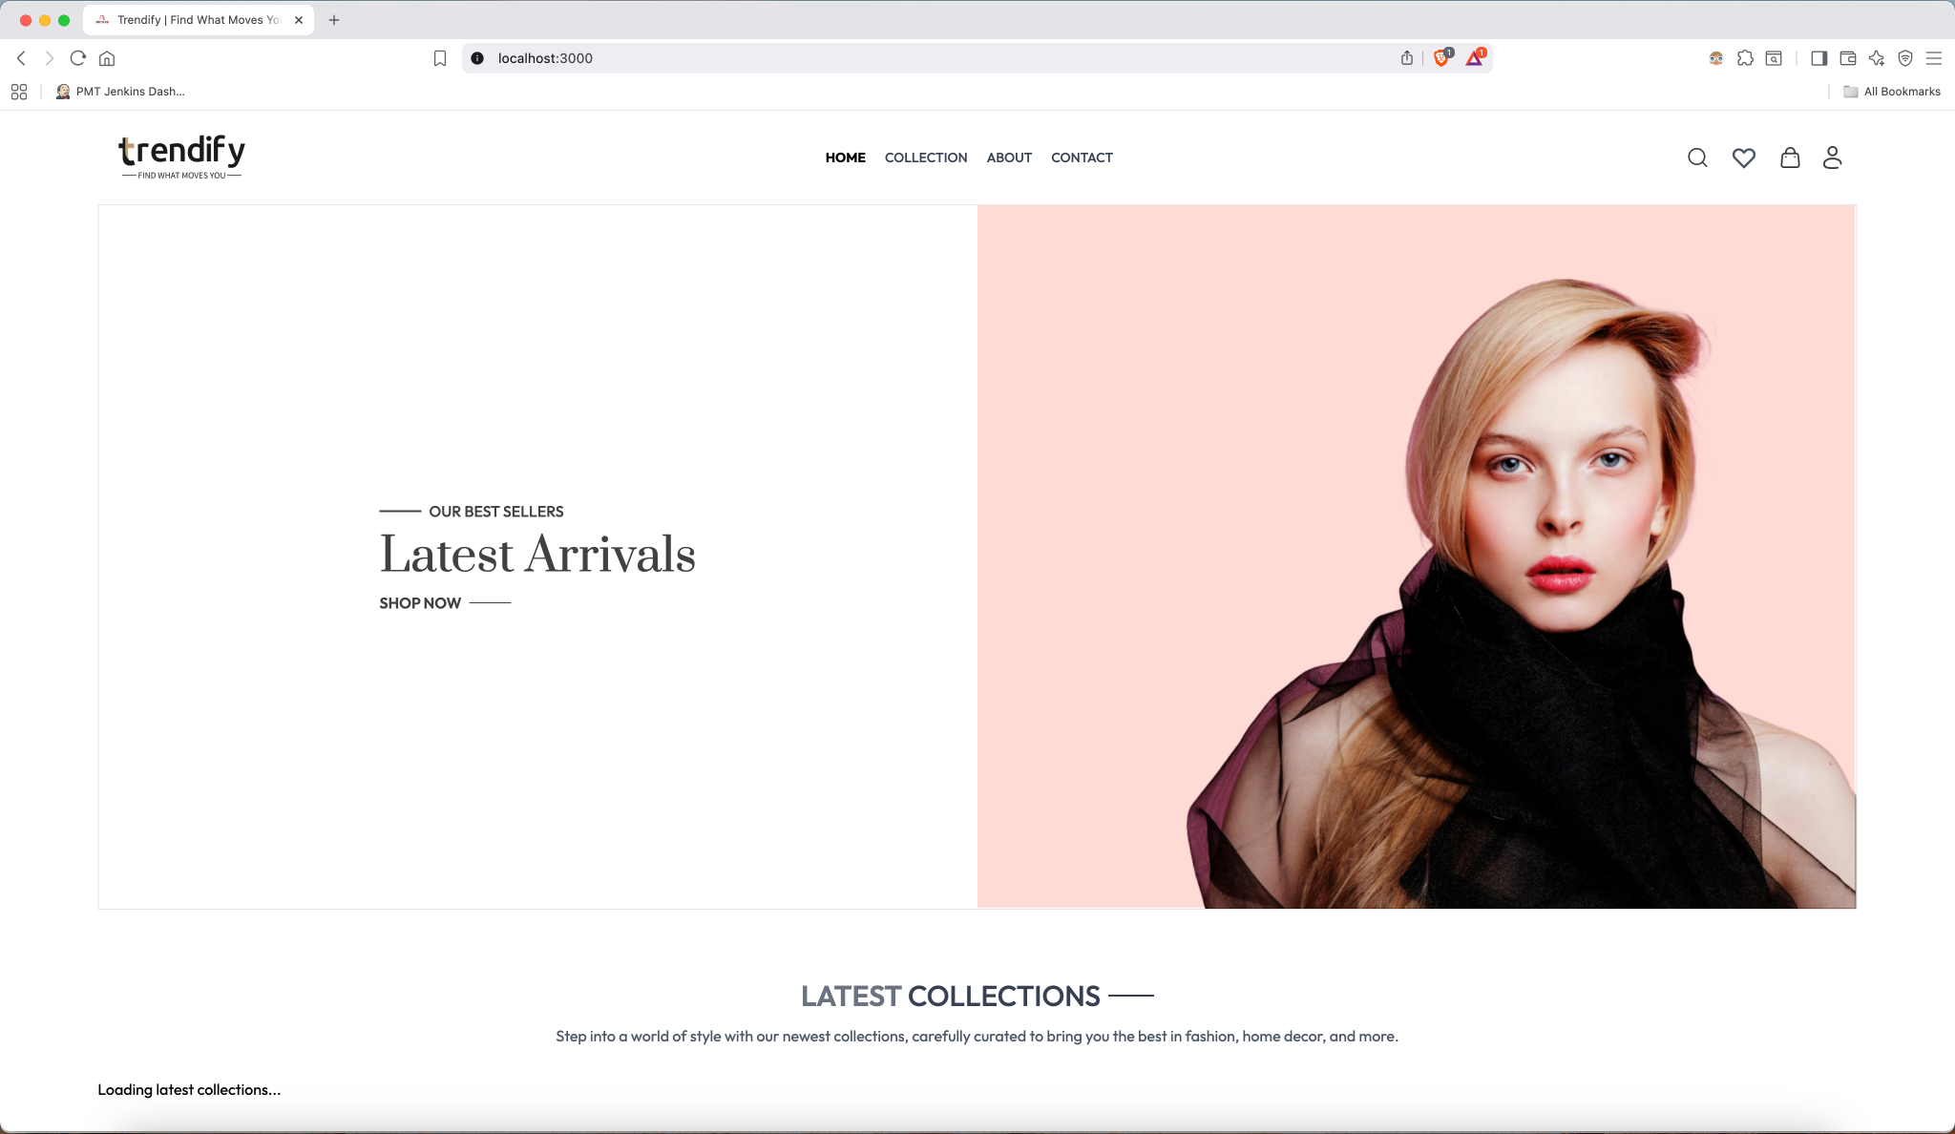

2d) Create new DockerHub Repo

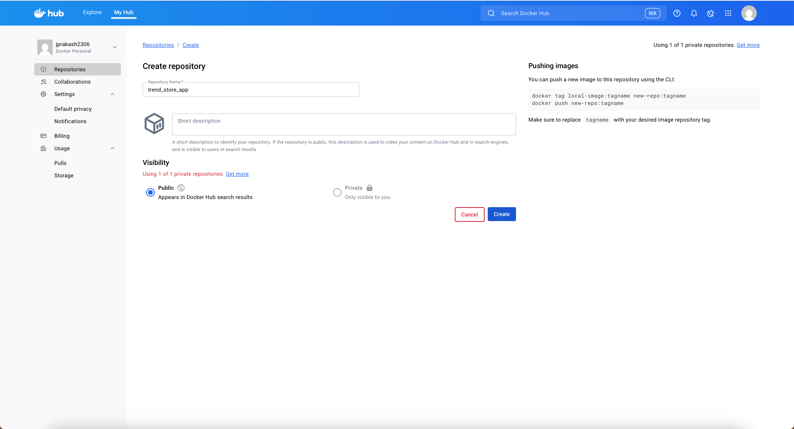

2e) Create new AccessToken to Push the image

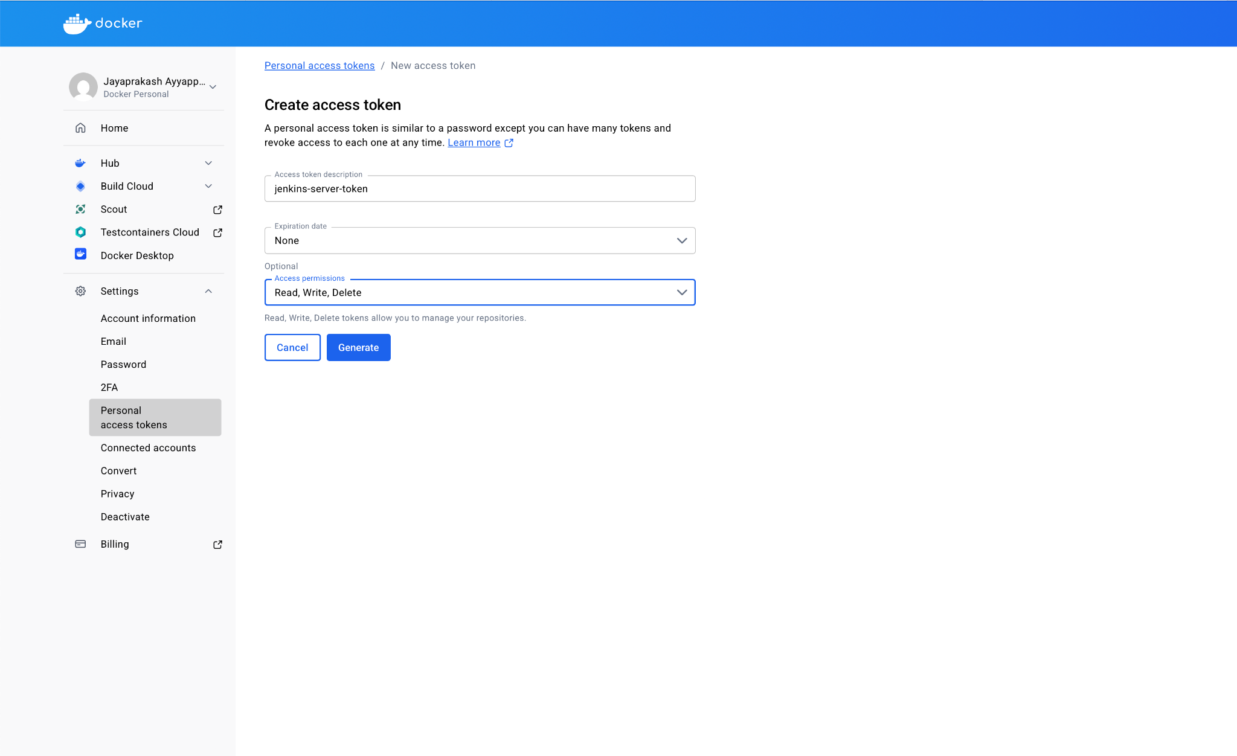

—---------------------------------------------------------------------------------------------------------------------------------------------------------

**3. Terraform**

3a) Create new SSh key for new EC2 jenkins-server

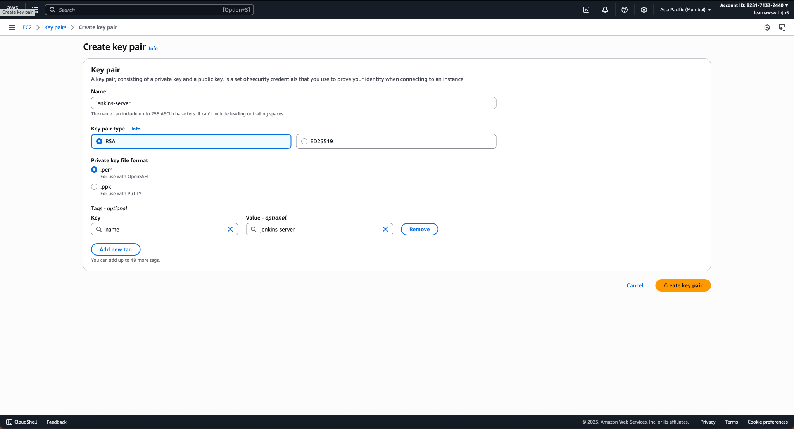

3b) Adding permission to ssh key

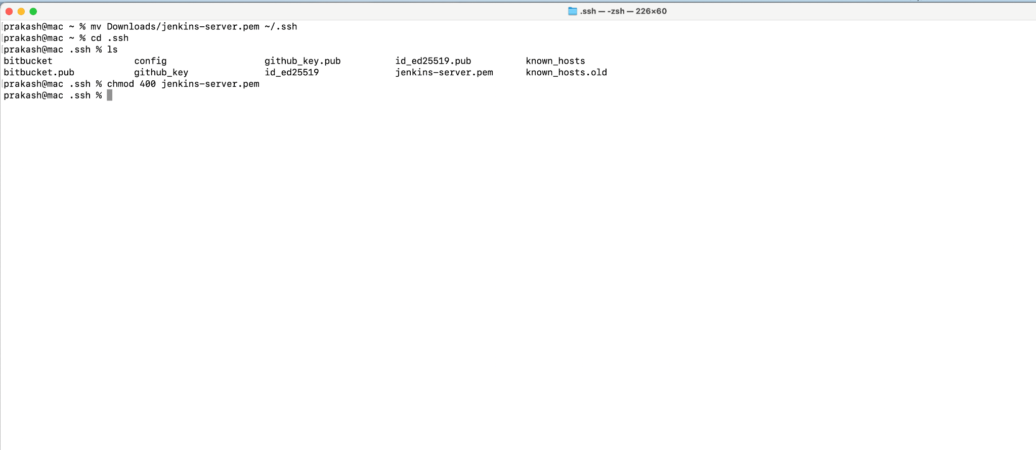

3c) terraform init command

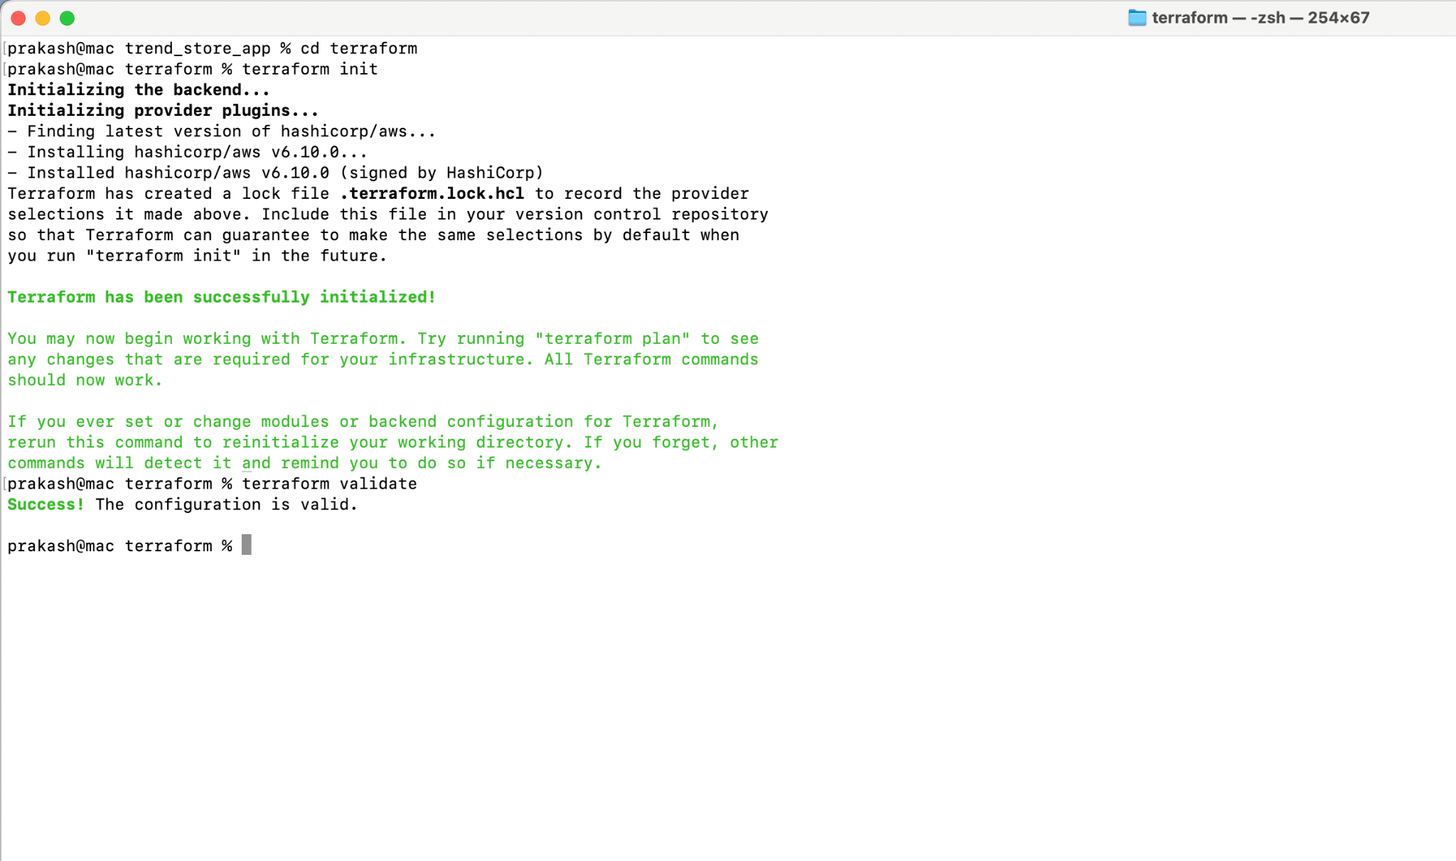

3d) terraform validate command

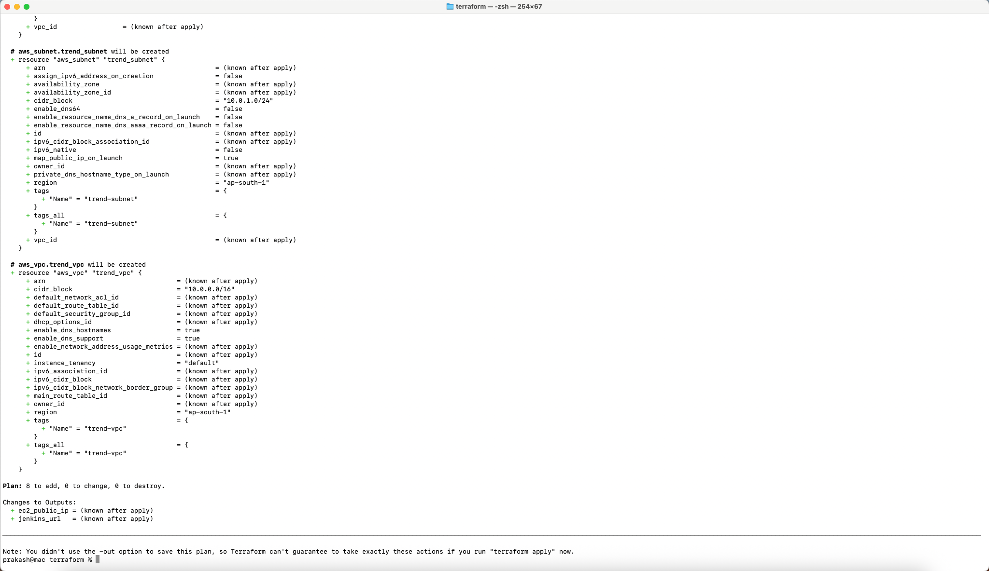

3e) terraform apply auto-approve command

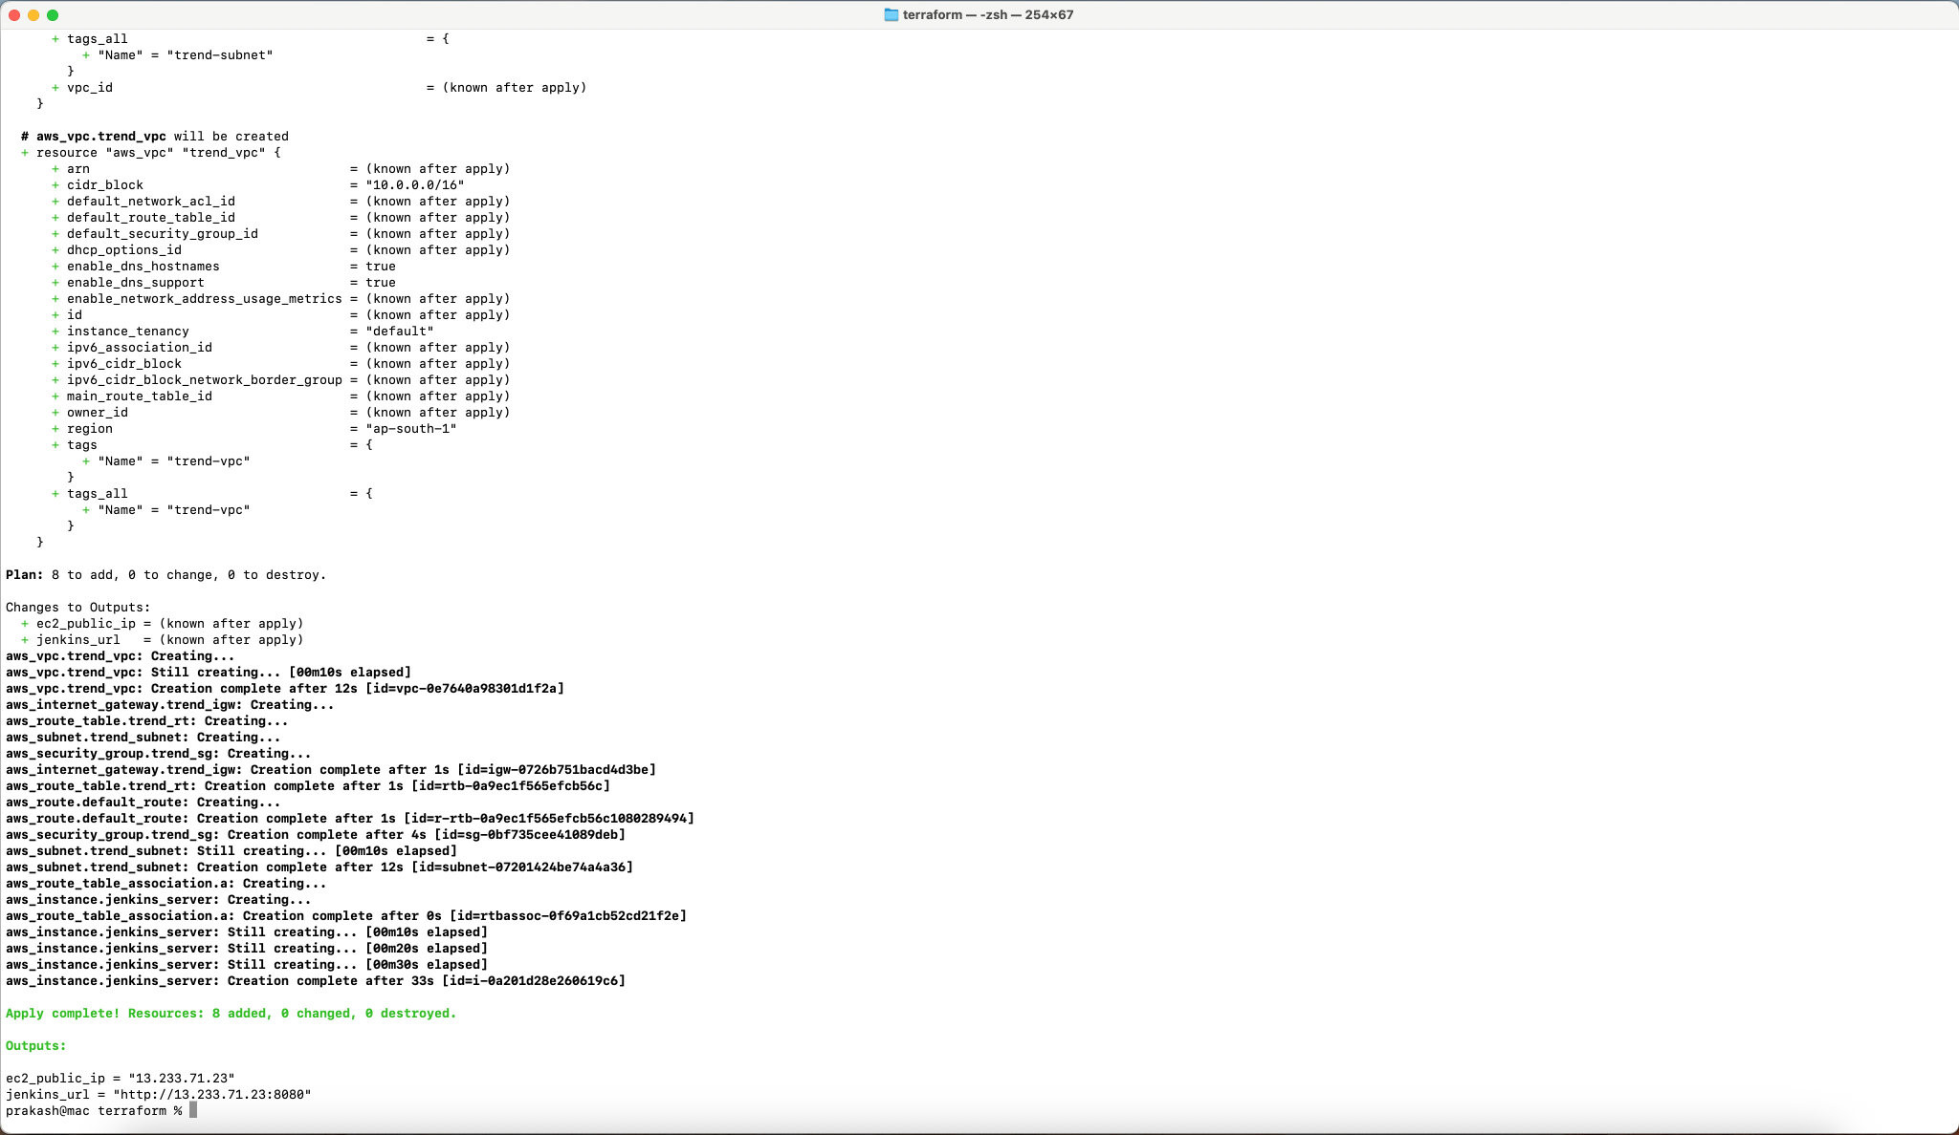

3f) EC2 created successfully via Terraform

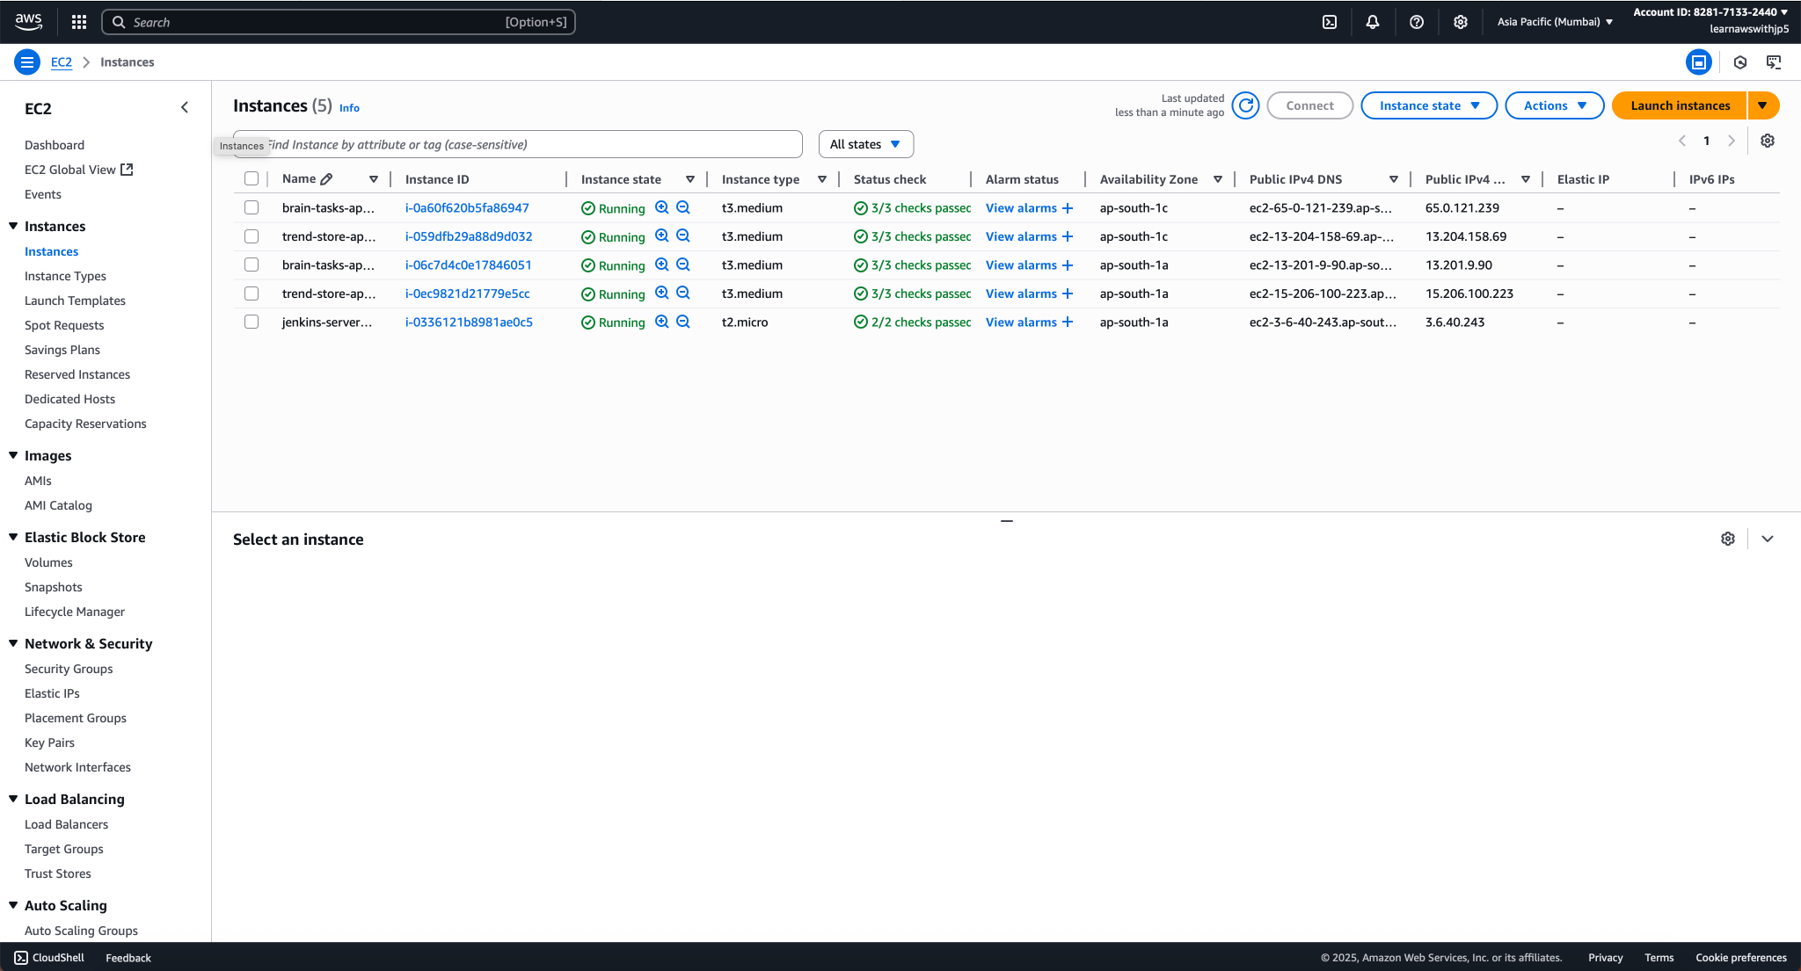

3g) EC2 created and logged via ssh key

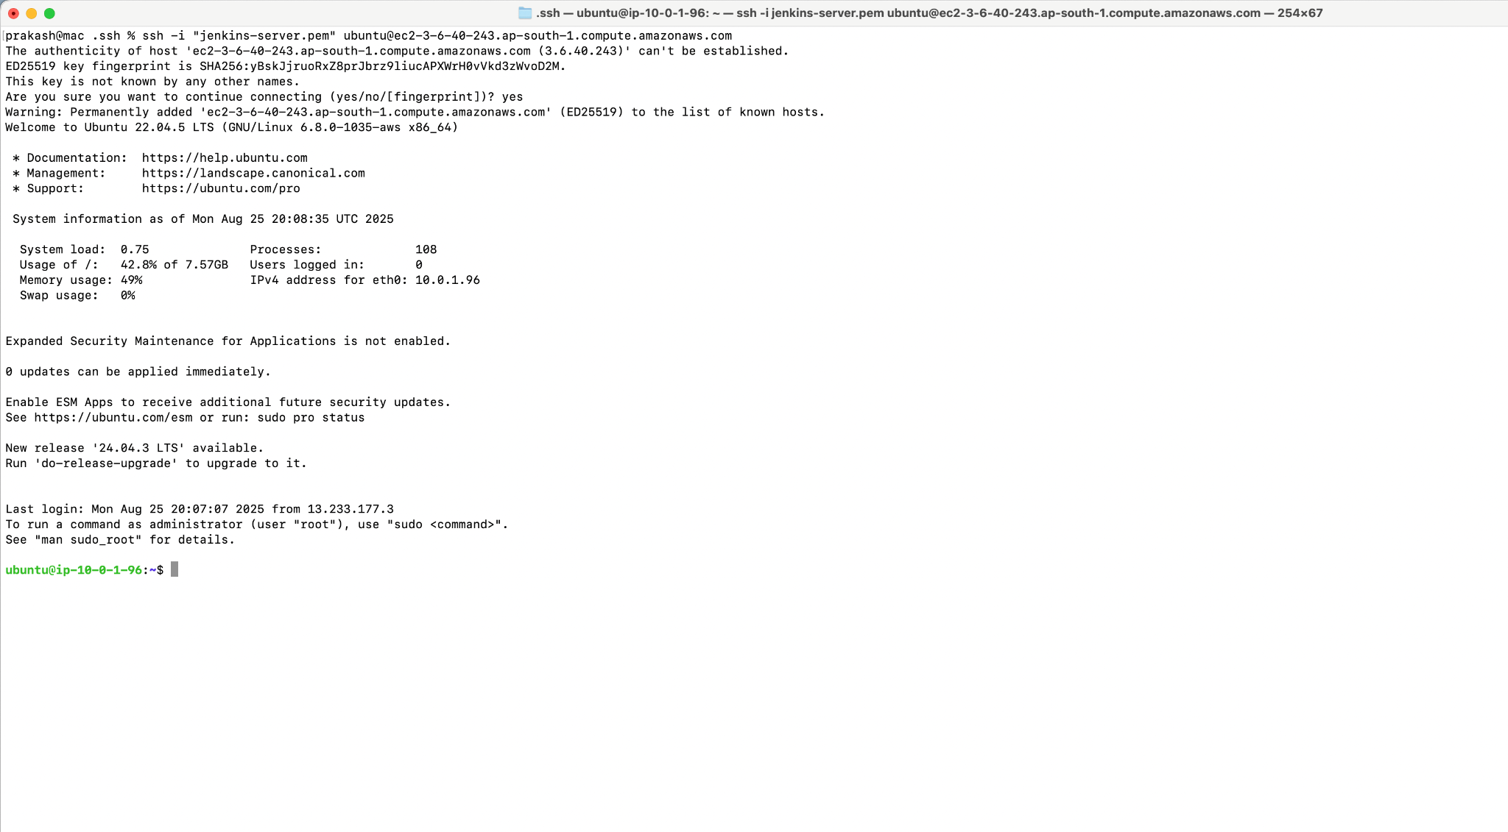

—-------------------------------------------------------------------------------------------------

**4. EKS setup and Config**

4a) New cluster trend-store-app created

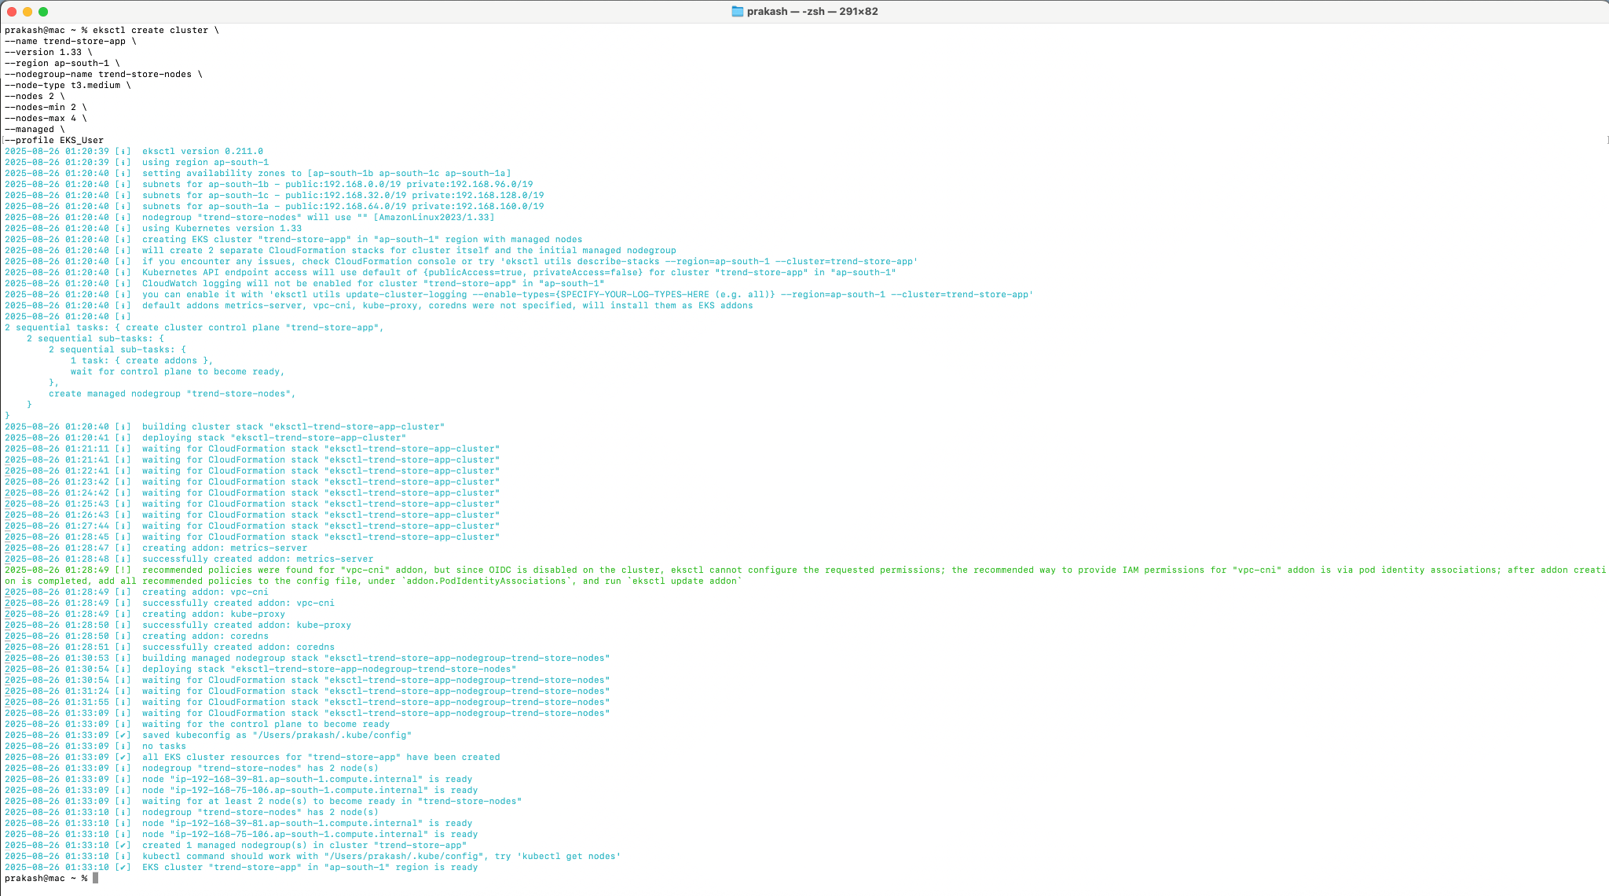

4b) eks setup verification and get pods commands

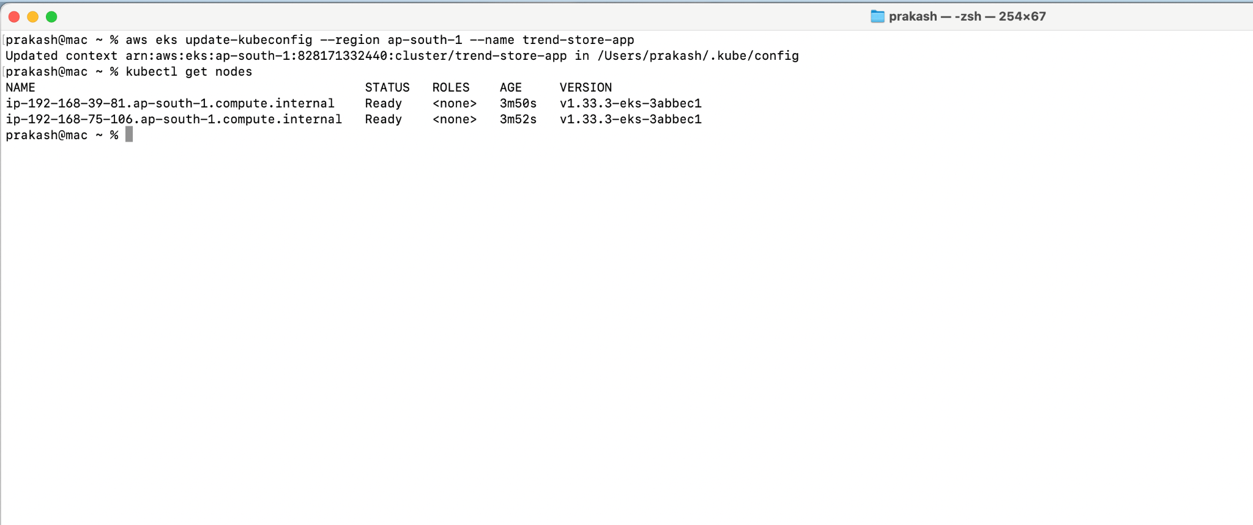

—-------------------------------------------------------------------------------------------------

**5. GitHub setup**

5a) New GitHub Repo

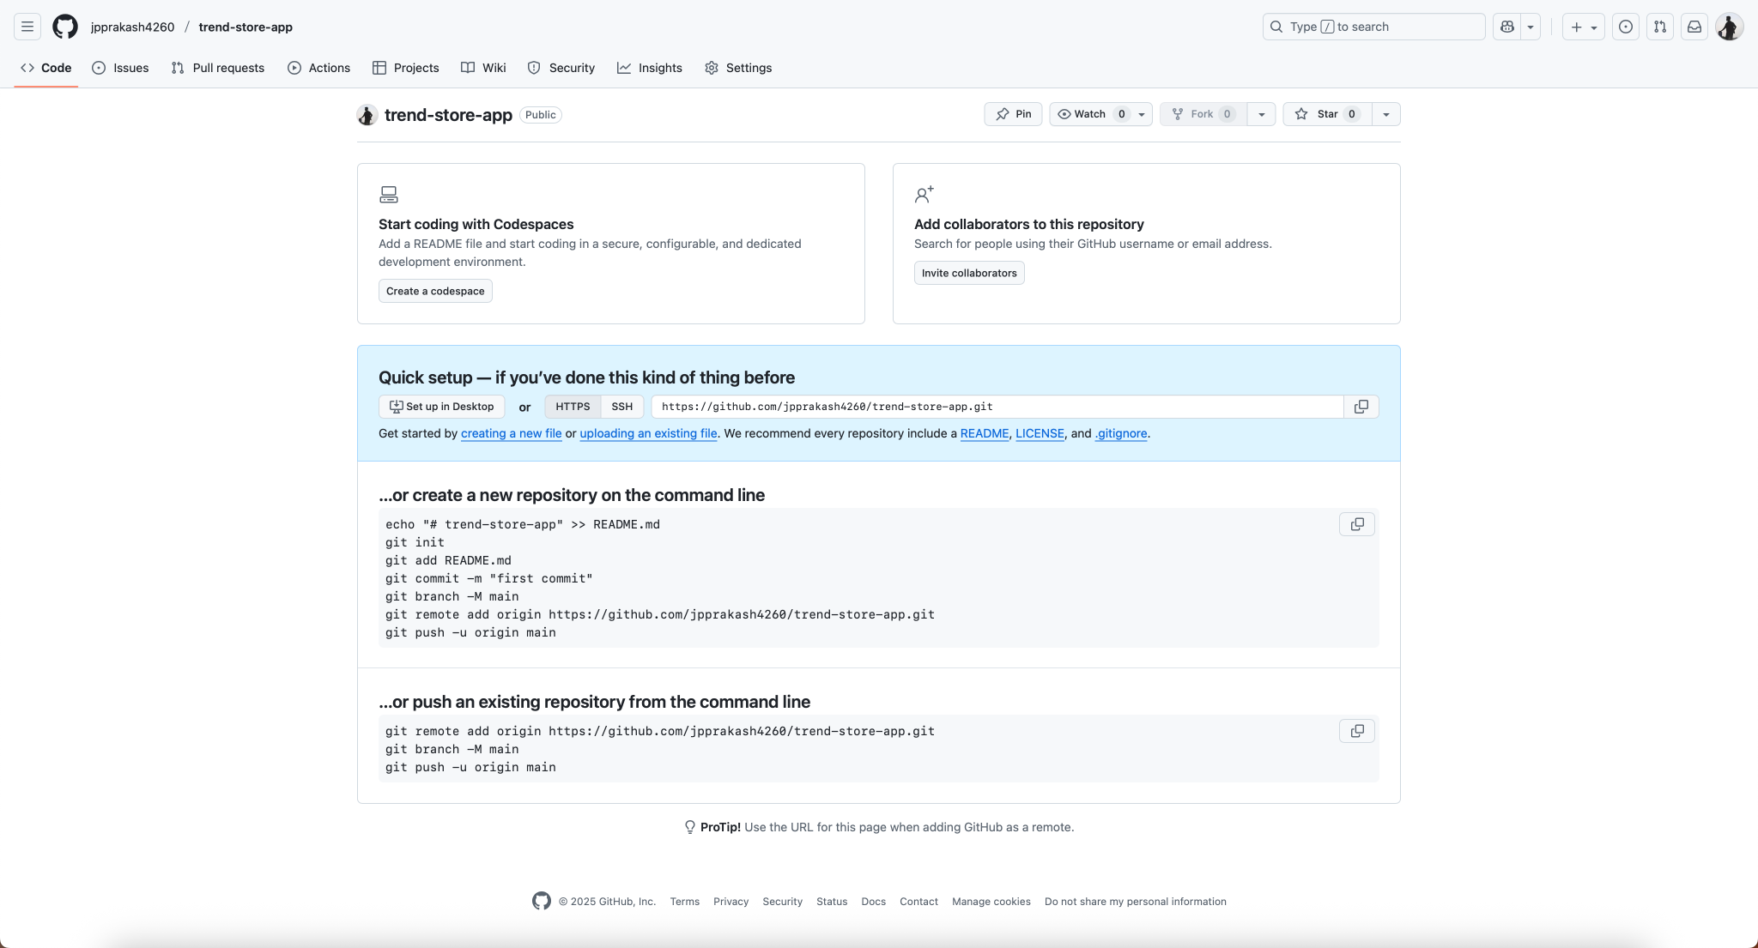

5b) Git commit and pushing commands

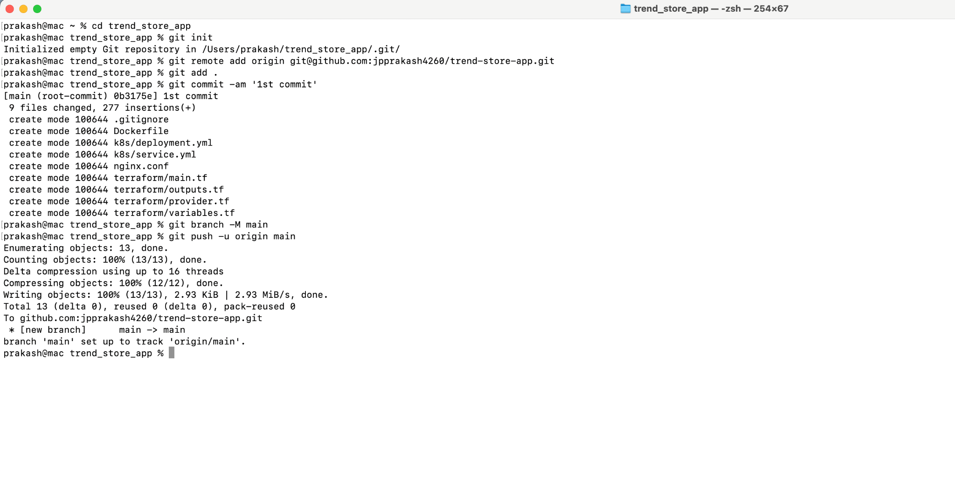

5c) Webhook Configuration to trigger Jenkins job

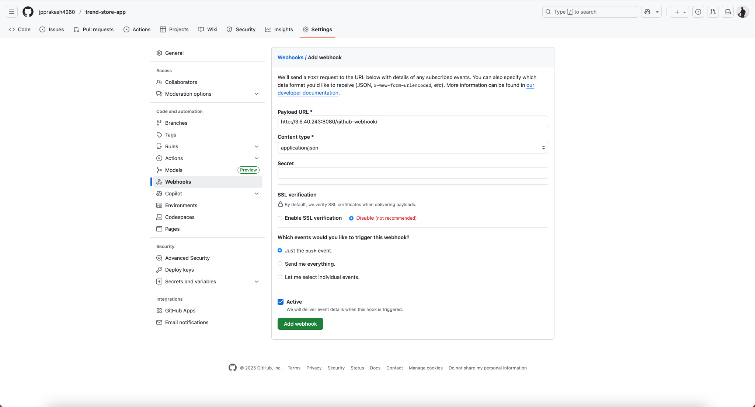

5d) delivery verification

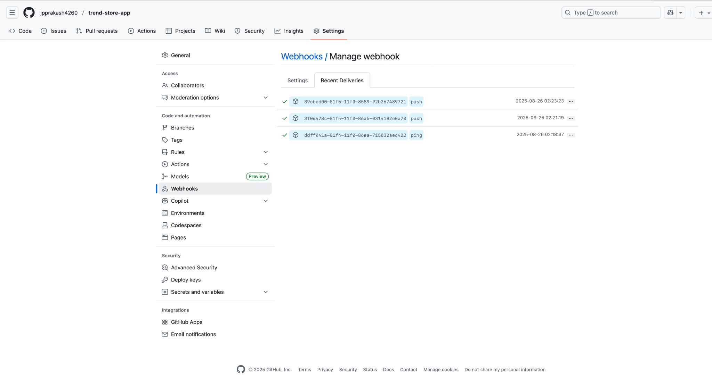

—-------------------------------------------------------------------------------------------------

**6. Jenkins Setup and Config**

6a) jenkins works on default 8080 port

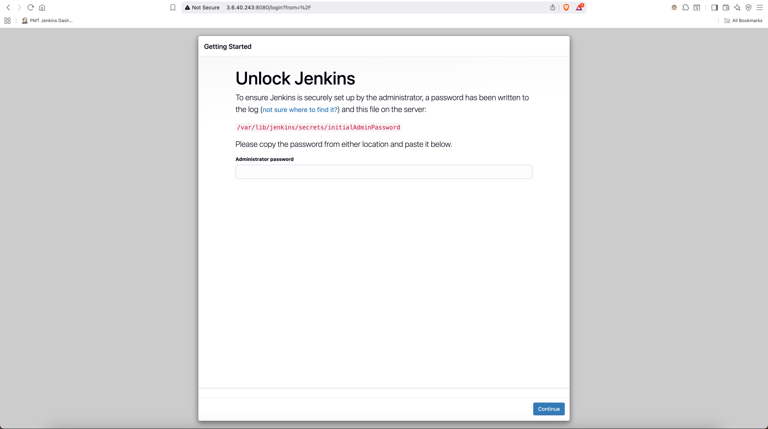

6b) get initial password

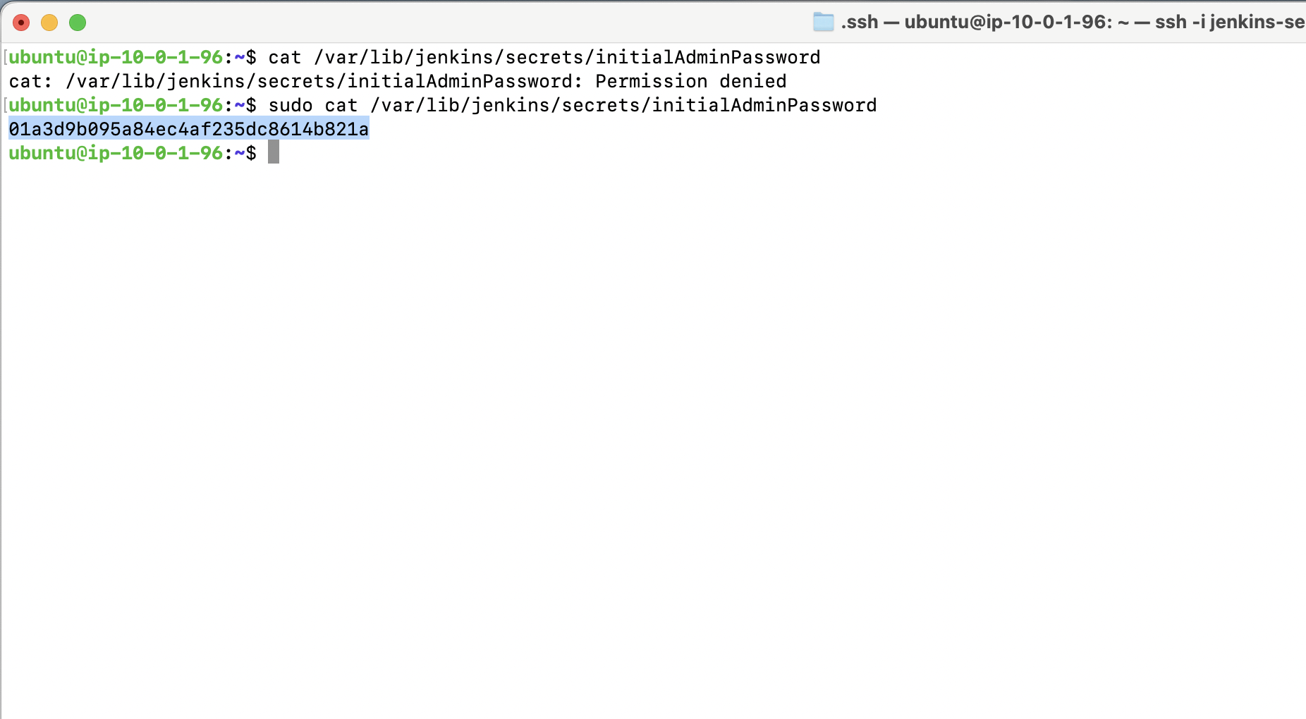

6c) Jenkins Initial Plugin setup

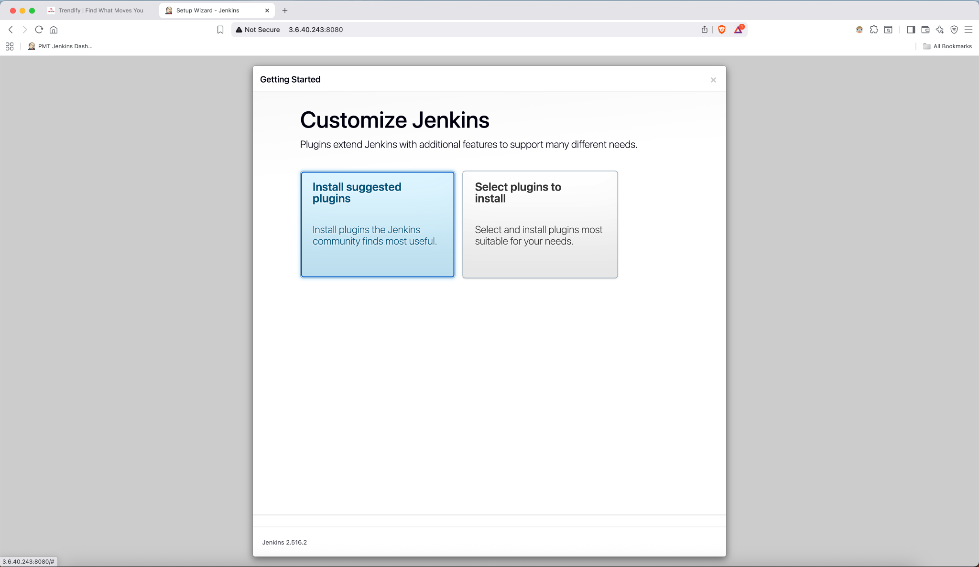

6d) Create New Admin User

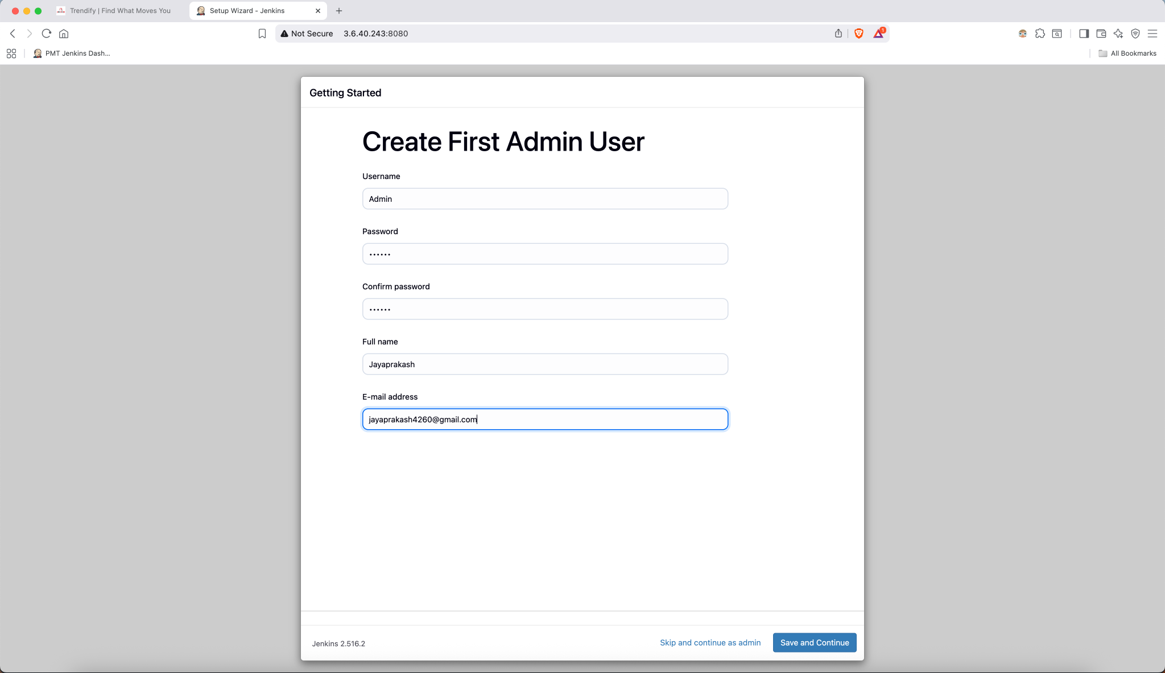

6e) Installing Essential Plugins like Git, Docker, kubernetes, stage view

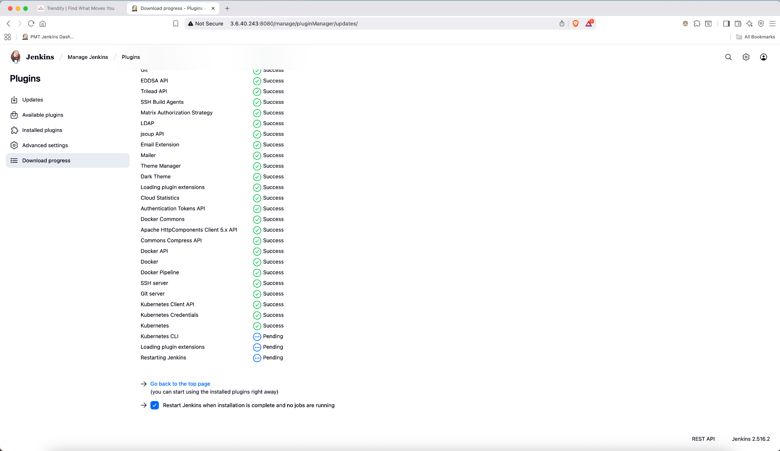

6f) Adding Docker Credentials to Jenkins Credentials Globally

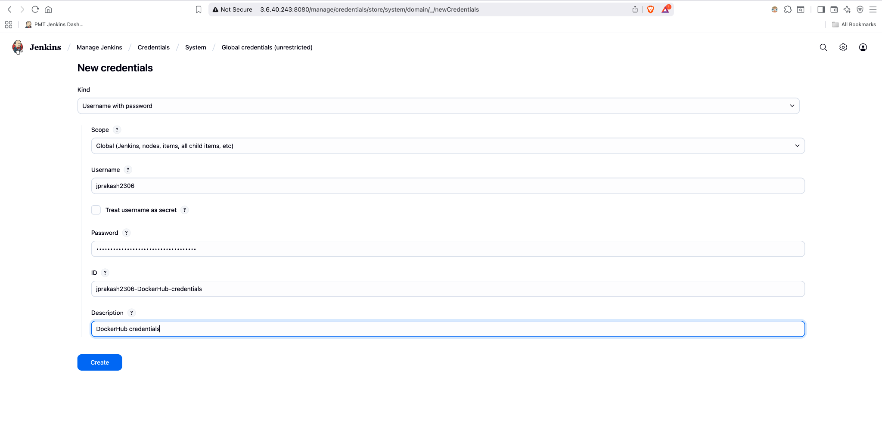

6g) Creating New Pipeline Job

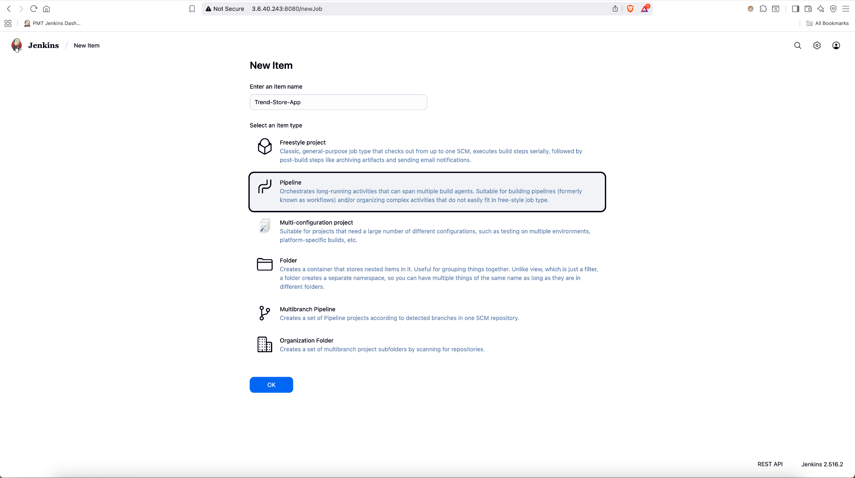

6h) Adding Jenkinsfile on project root folder

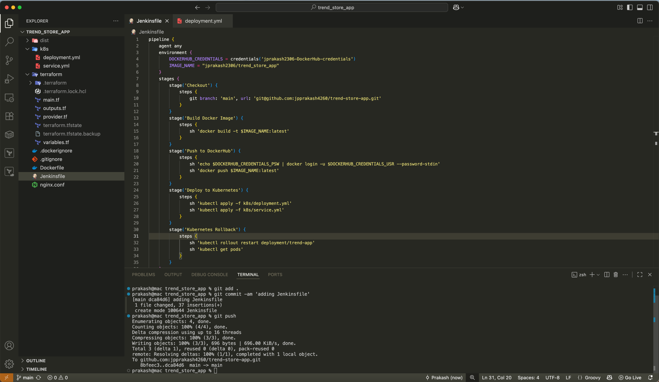

6i) Enabling Github Hook Trigger for Gitscm polling

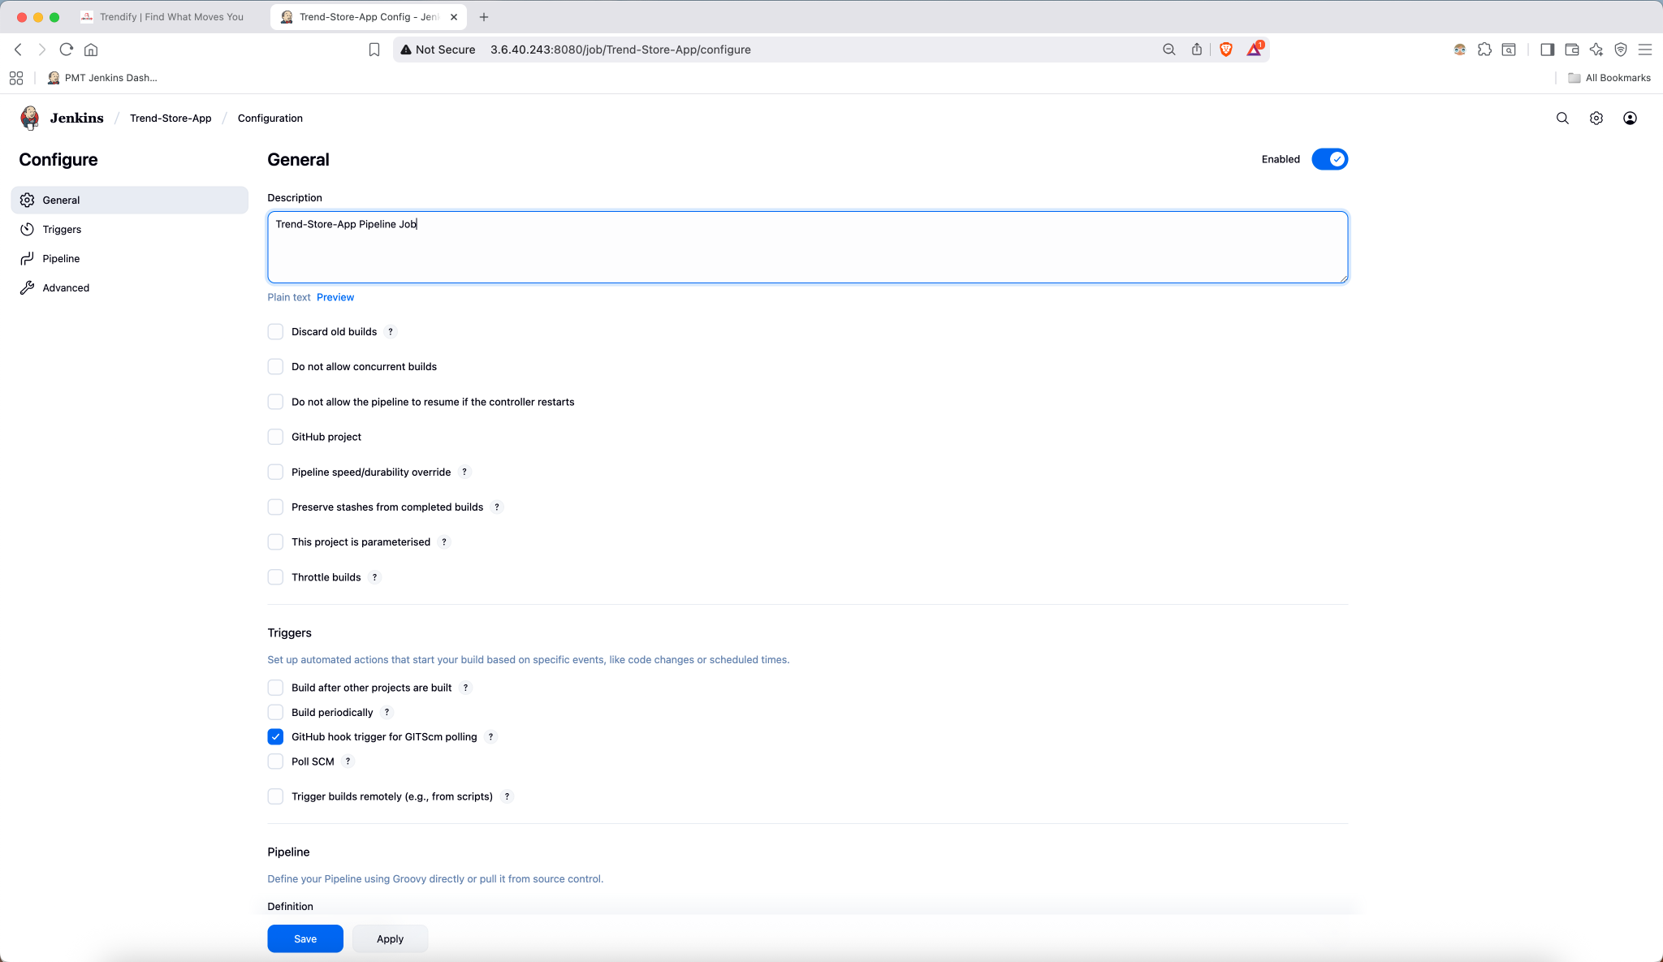

6j) get Jenkinsfile from project repo

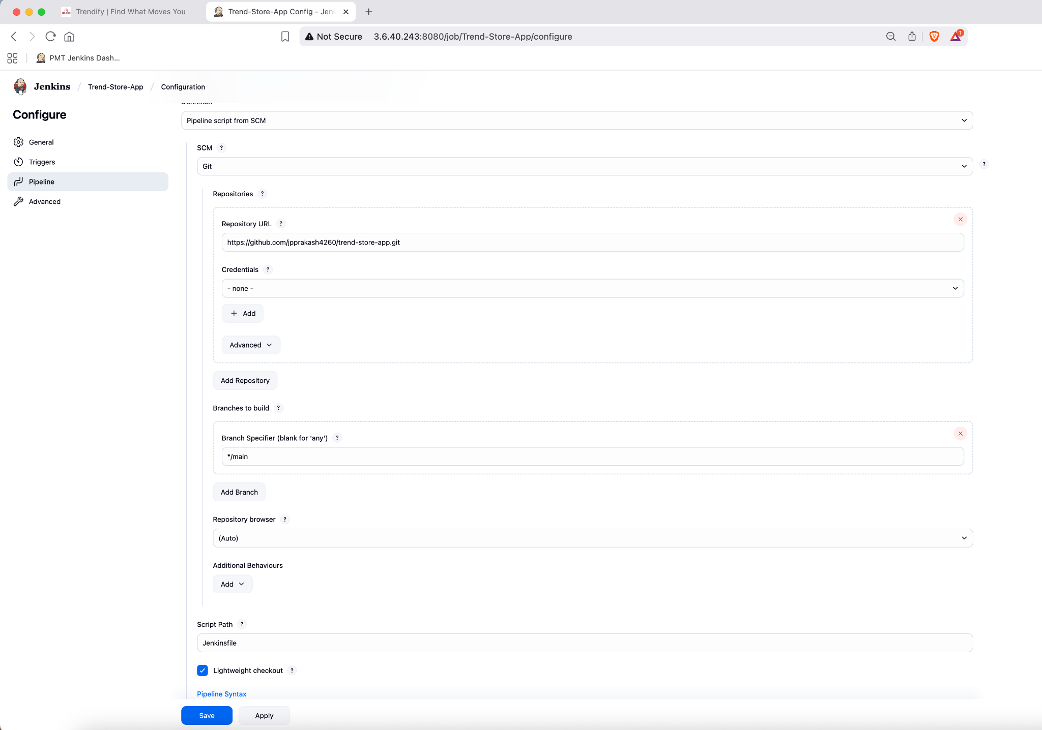

6k) installing kubectl for apply and rollout from Jenkins Pipeline

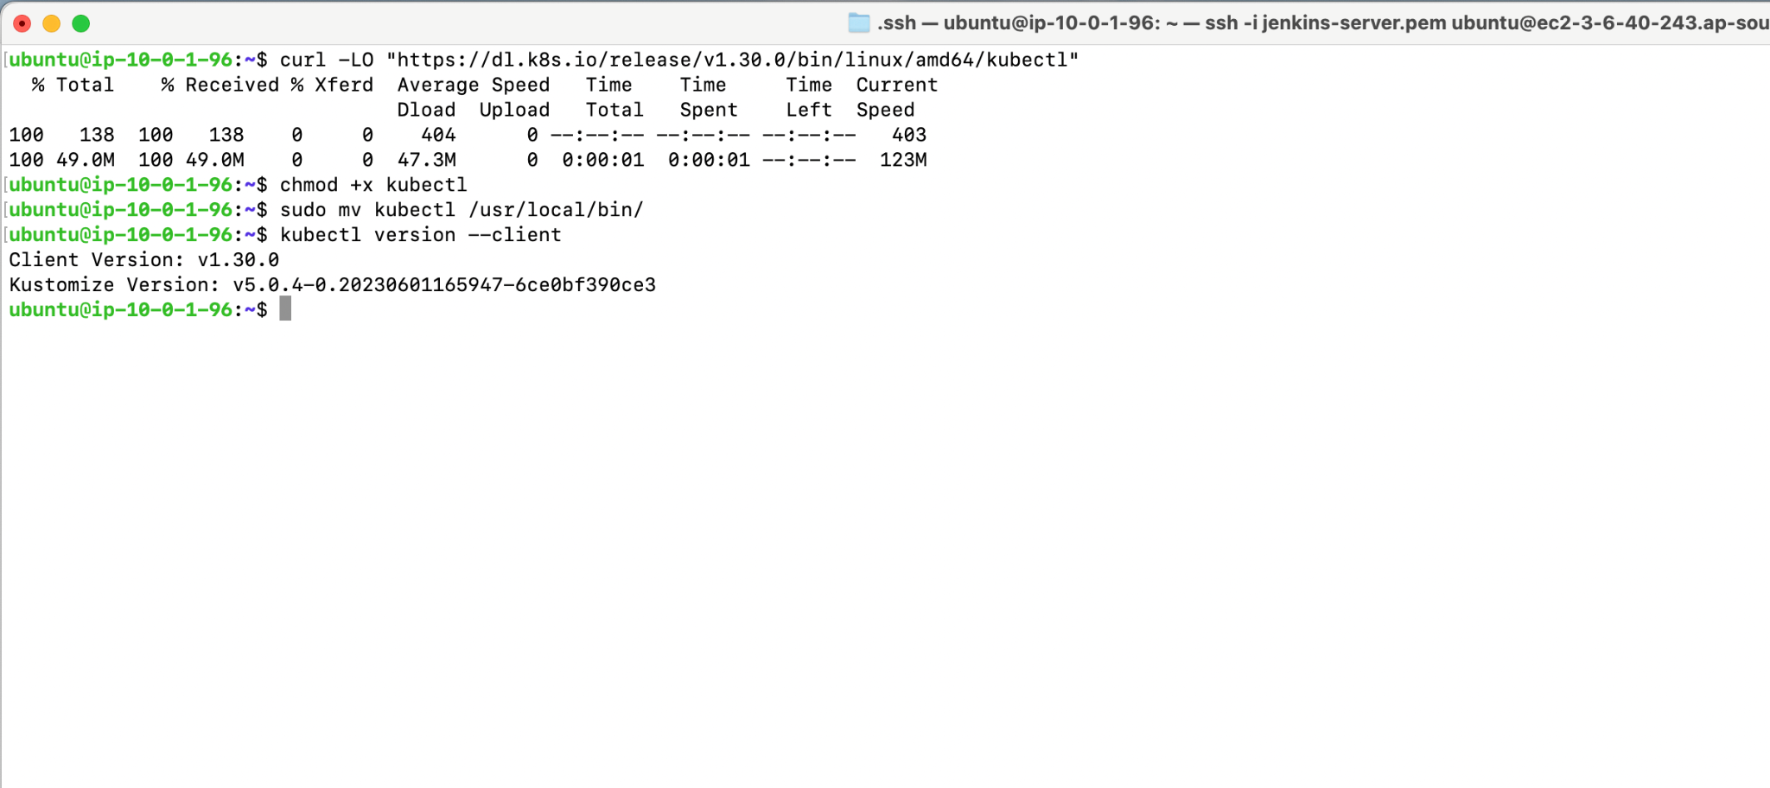

6l) AWS configure on EC2

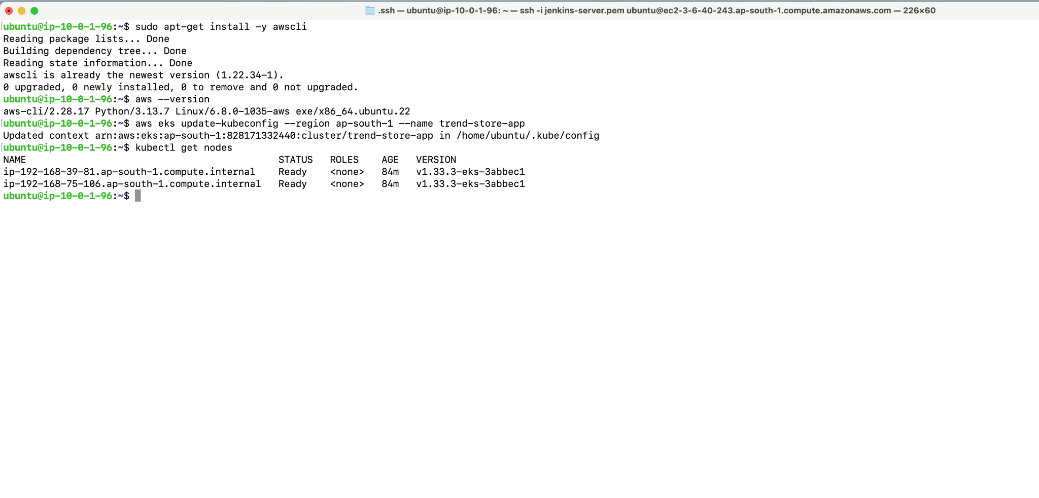

6m) Jenkins Pipeline Job Triggered Automatically

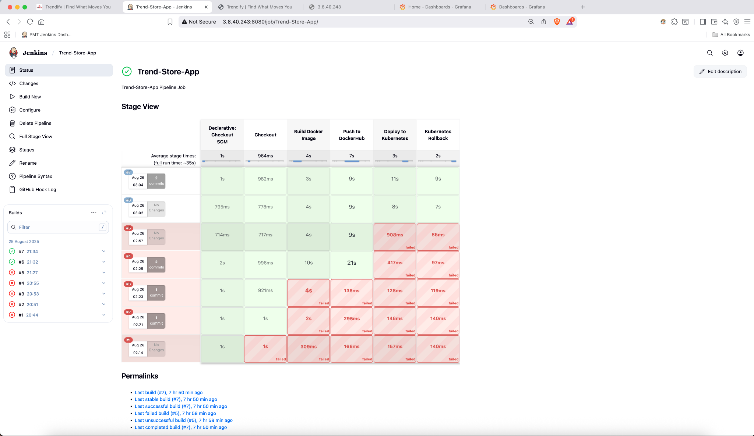

6n) Jenkins Pipeline Deployed App successfully

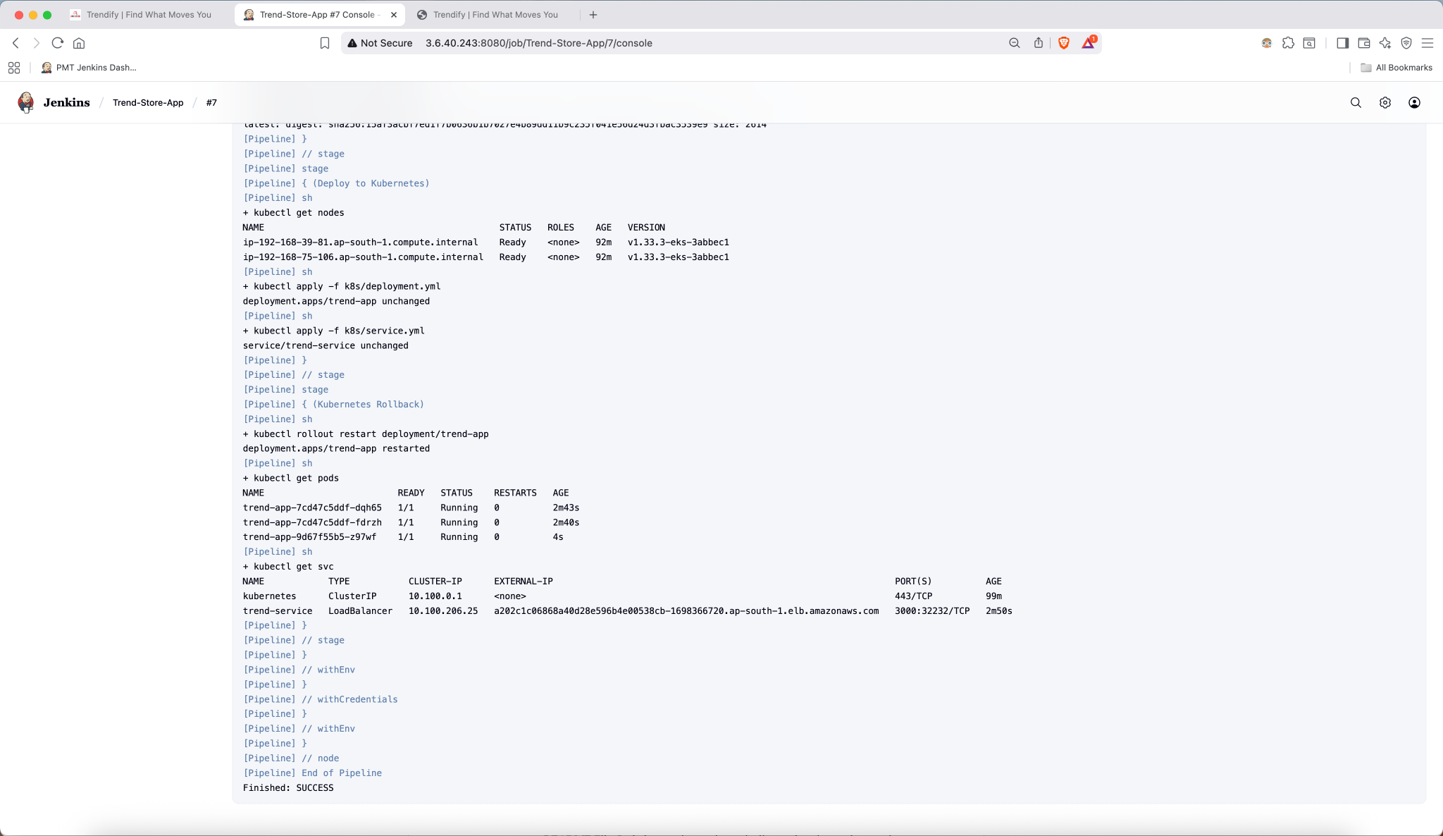

6o) App Running via EKS-cluster on 3000 port

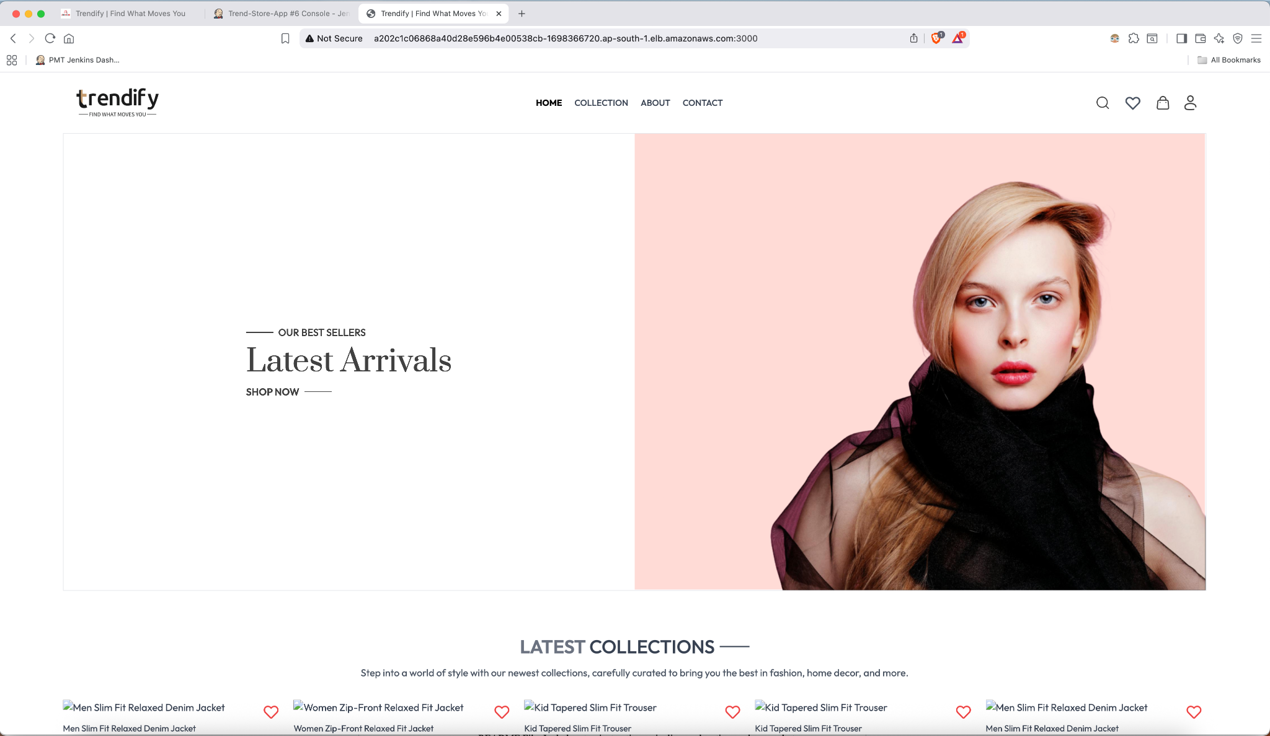

—-------------------------------------------------------------------------------------------------

**7. Monitoring**

7a) Installing Helm and Prometheus on new Namespace called monitoring

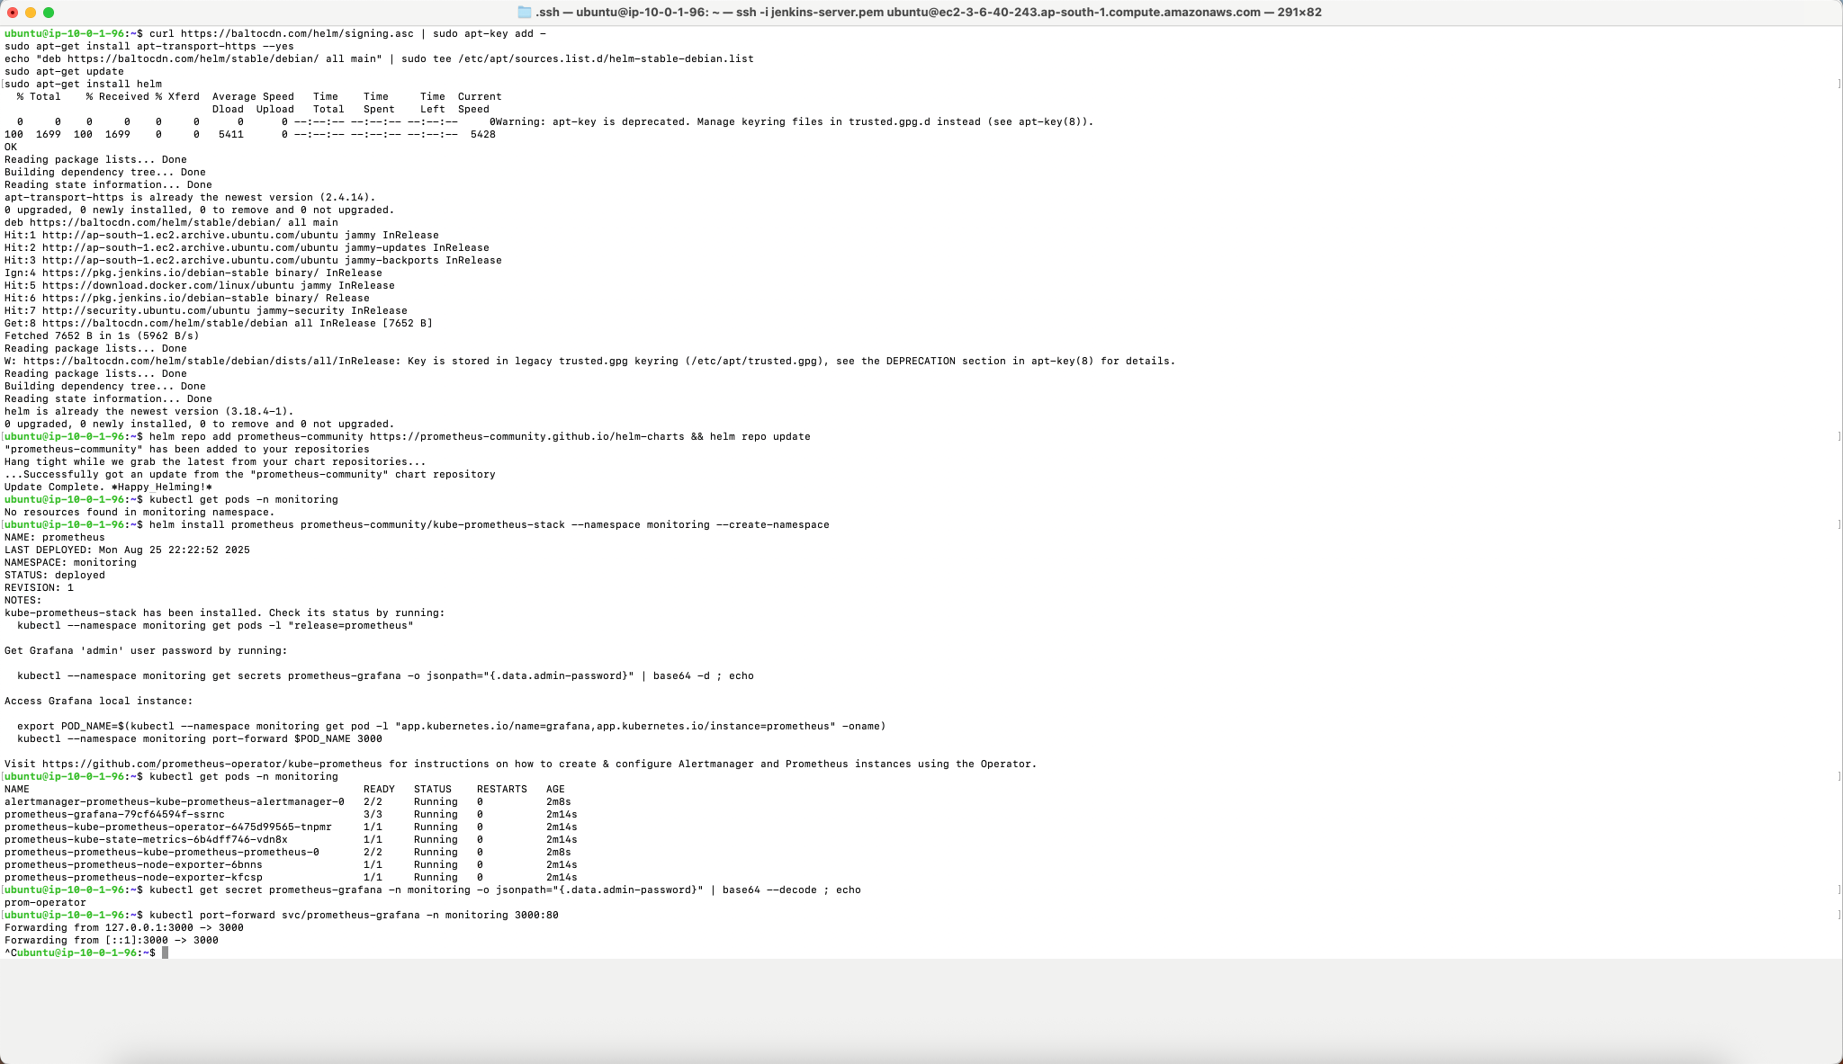

7b) Promethus configurations

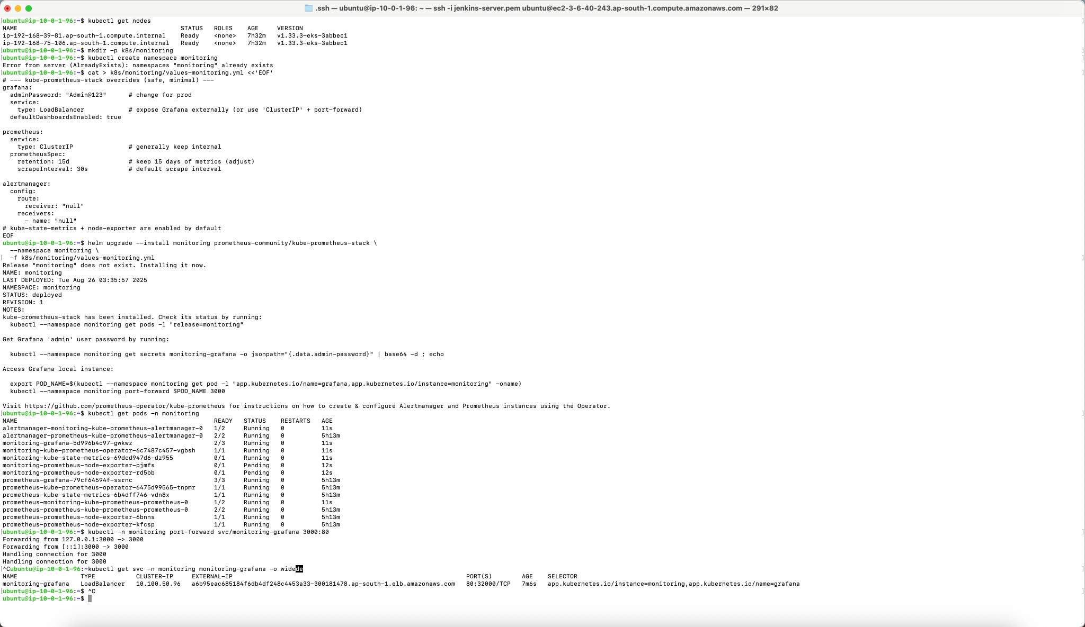

7c) Grafana Dashboard for EKS-cluster

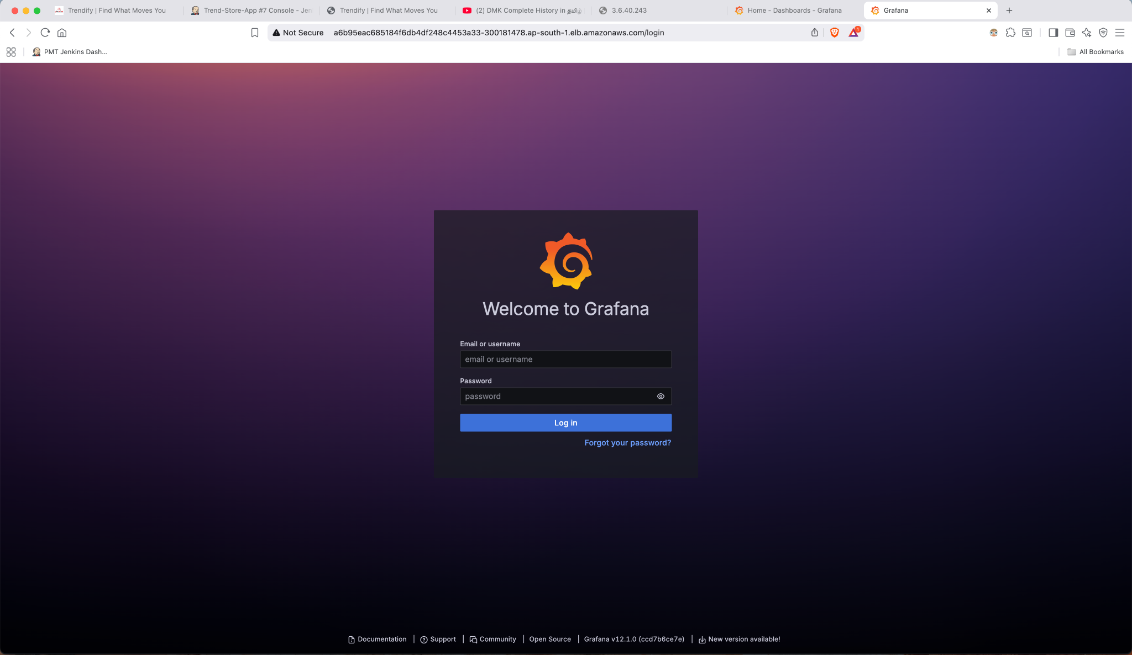

7d) trend-service.yml file configuration

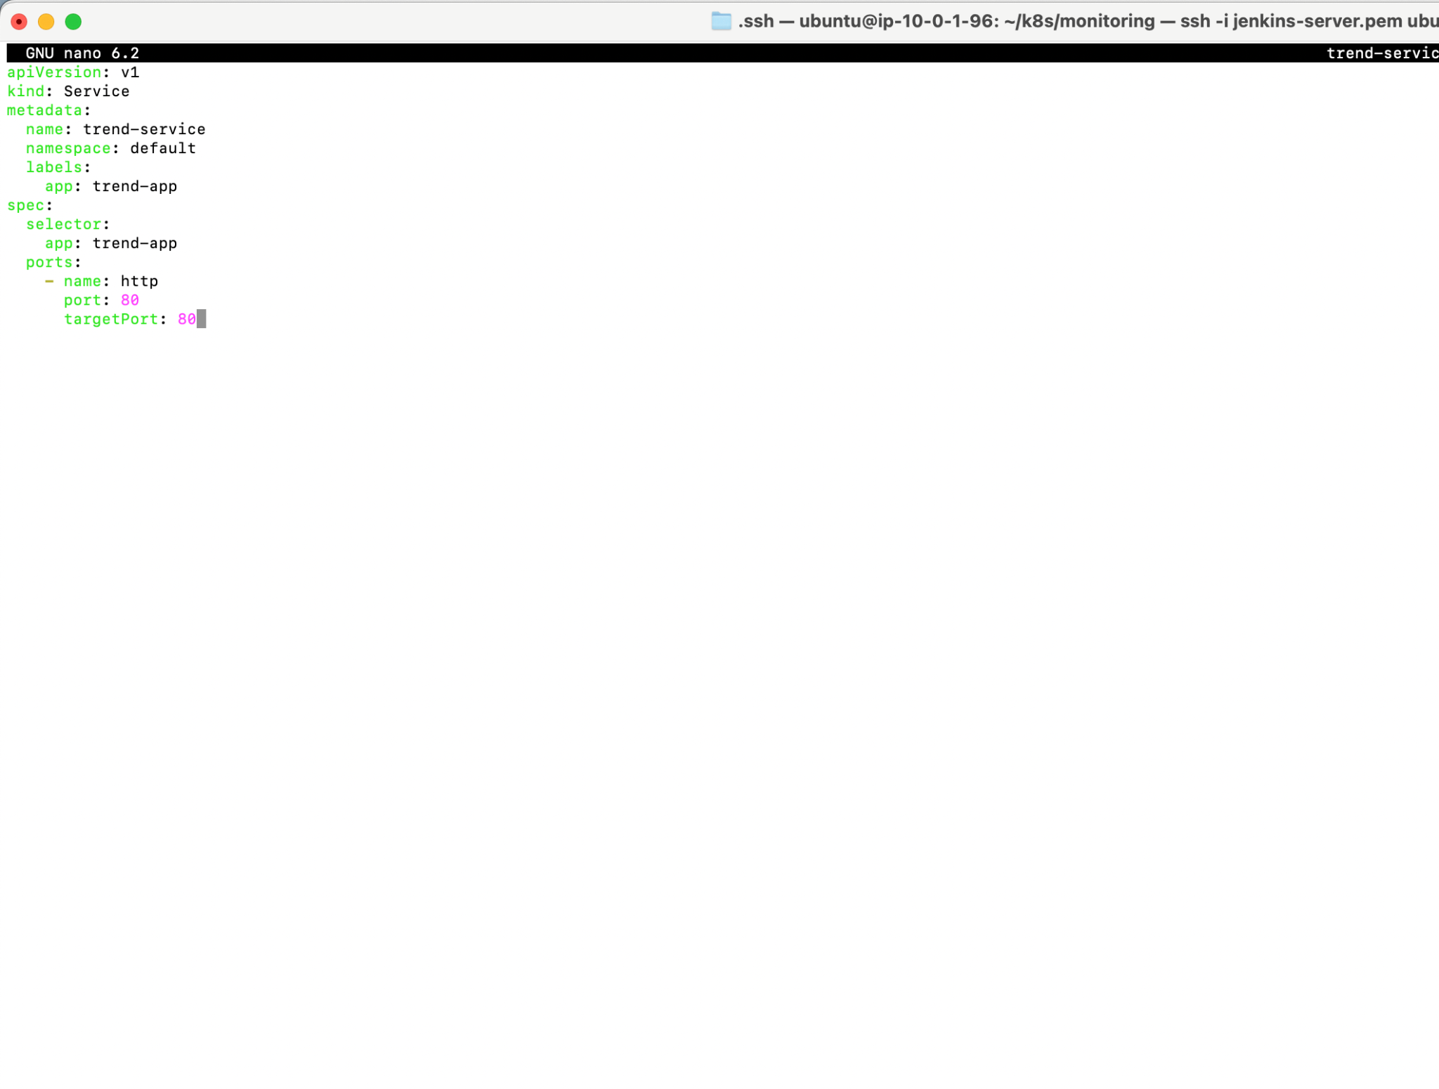

7e) alertmanager.yml file configuration

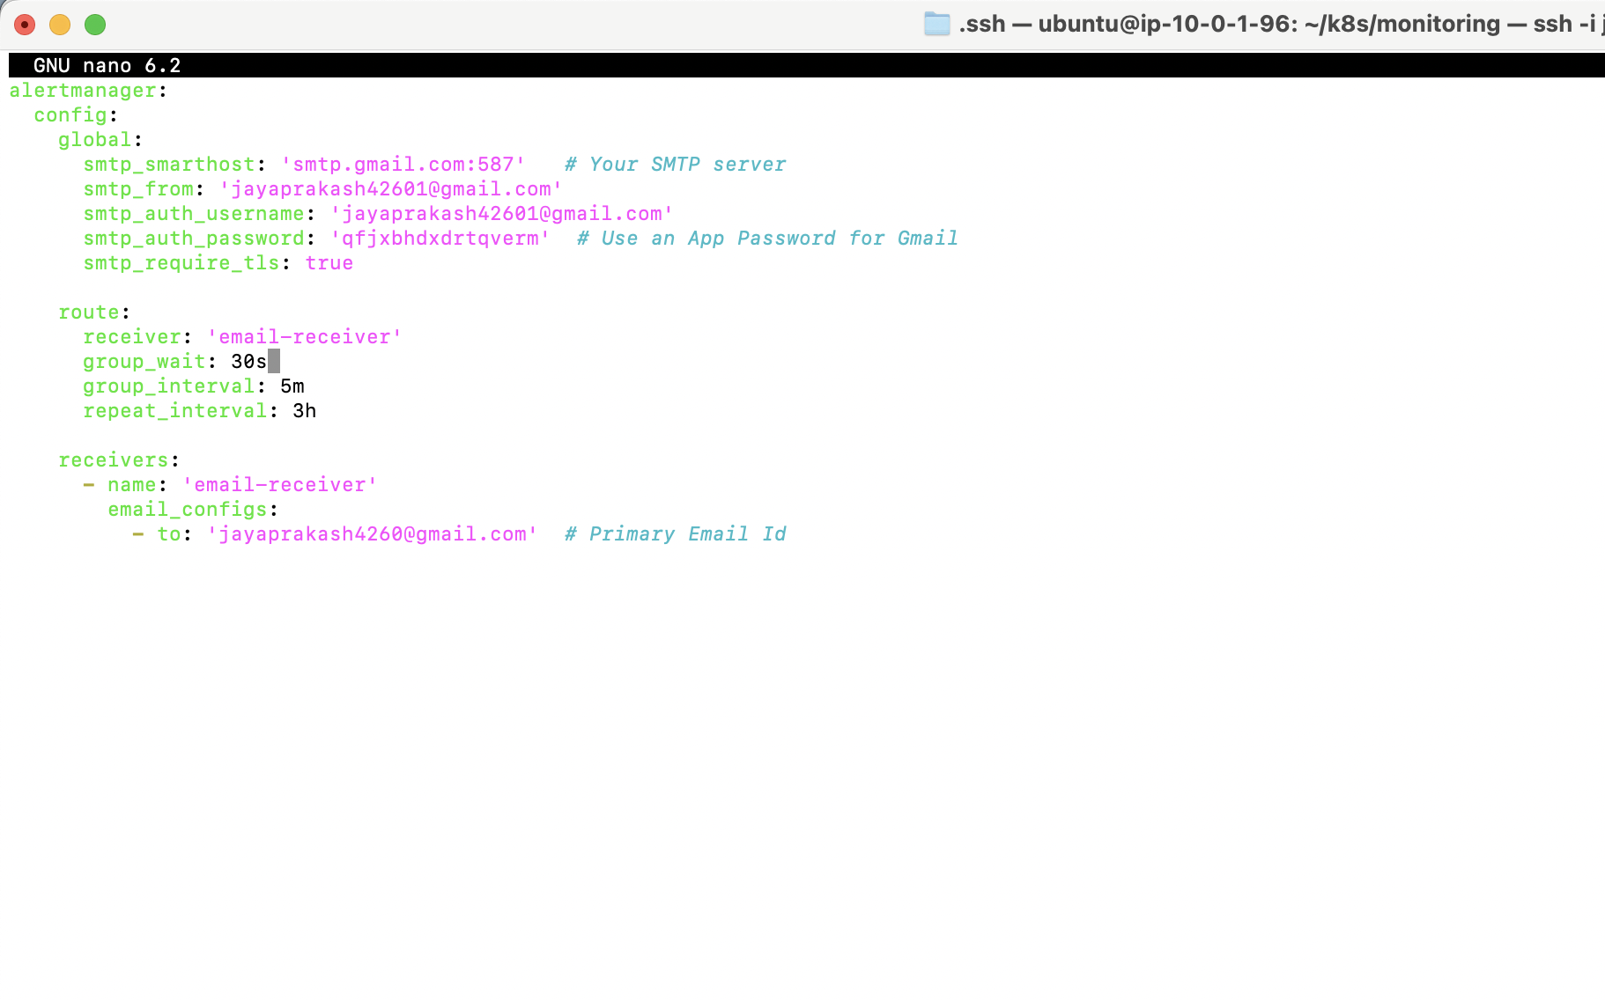

7f) Grafana Dashboard

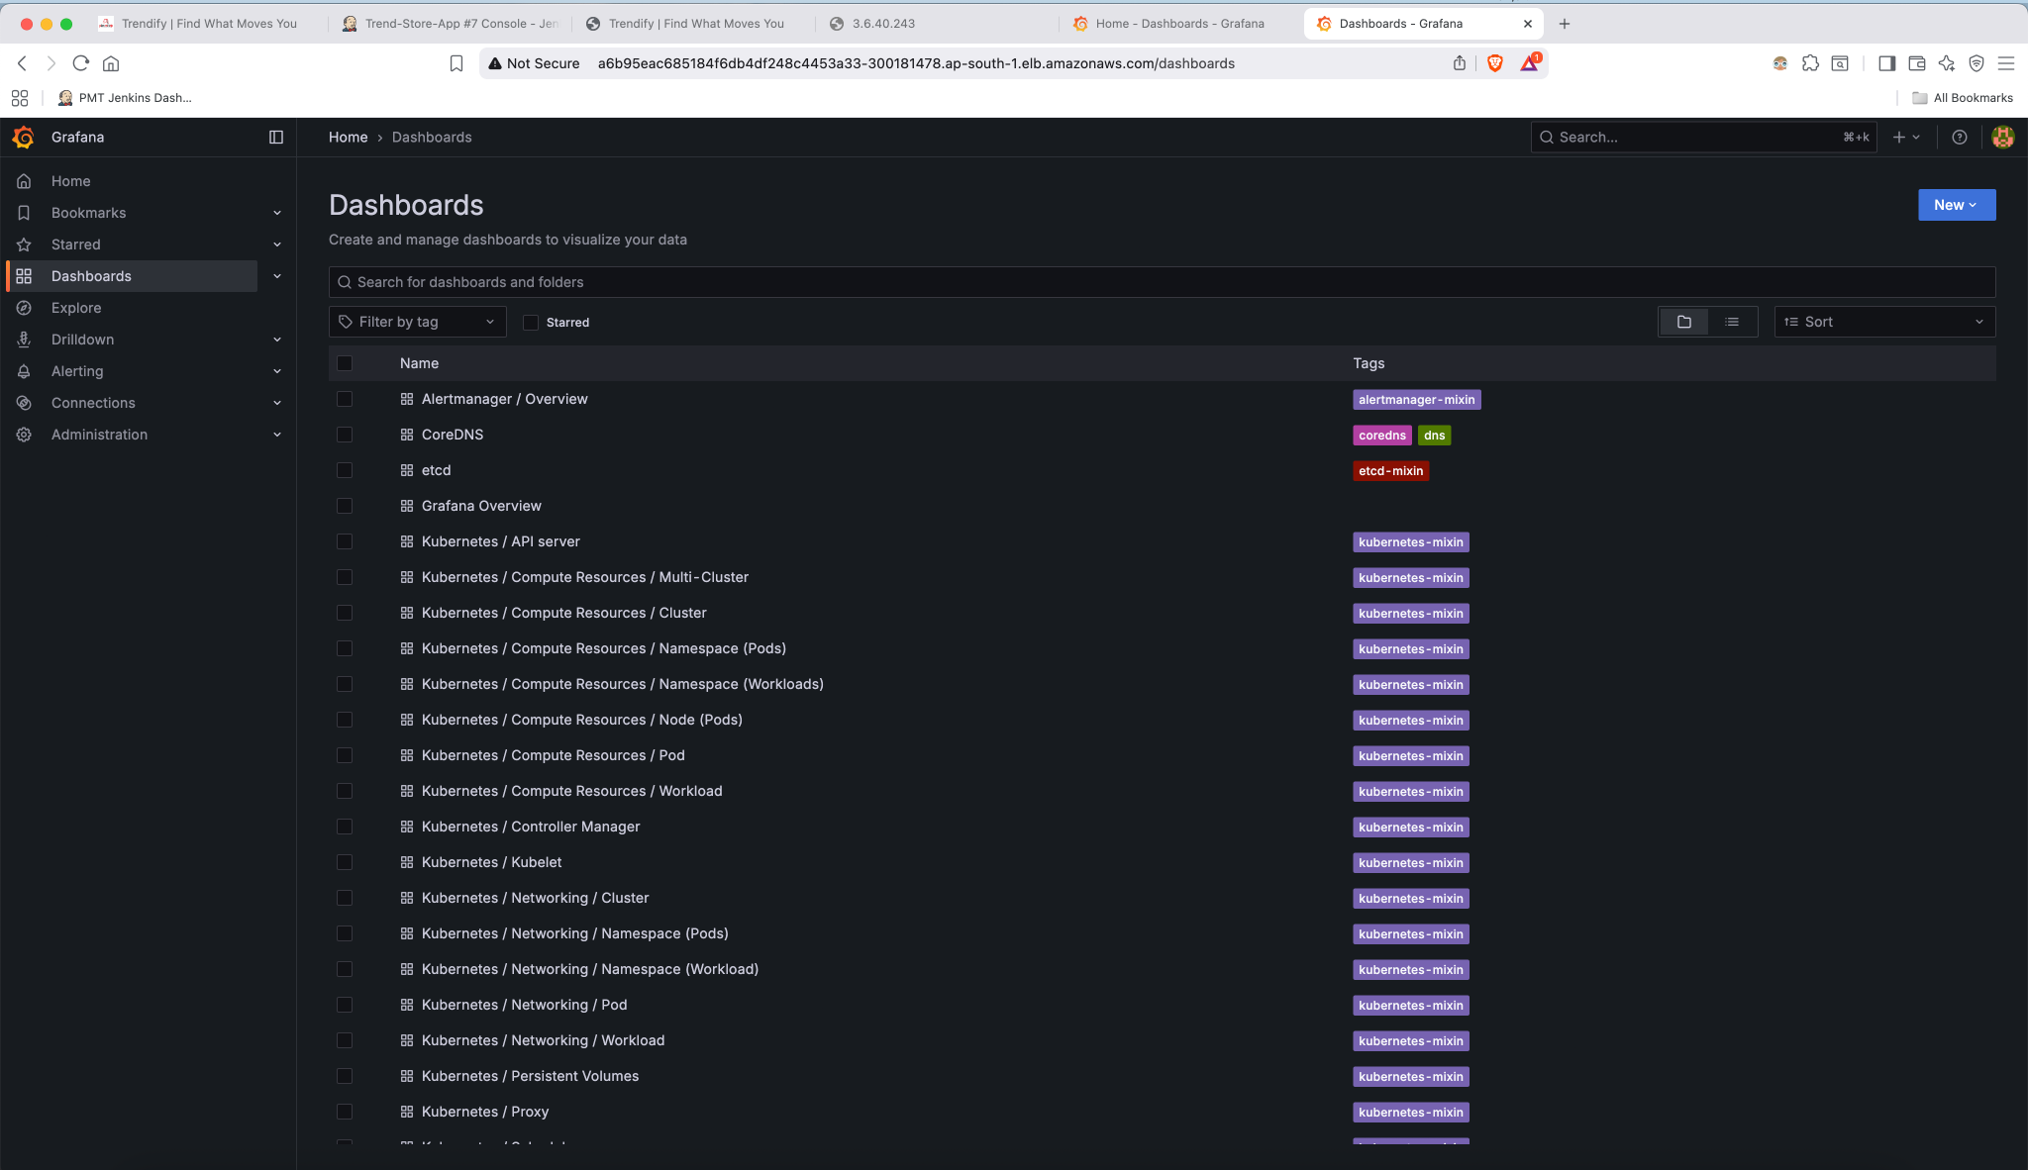

7g) Cluster's Dashboard View

